government of karnataka

DEPARTMENT OF STAMPS AND REGISTRATION


New Kaveri Functional Requirement Specification

October, 2012

Table of Contents
1 Executive Summary 3
2 Introduction 5
3 Scope of Work 8
4 Hybrid Architecture 9
5 Functional Architecture & Requirements 13
6 Annexure 1 – Transaction Statistics 90
7 Annexure 2 – Process Maps 91
8 Annexure 3: External Interfaces 119
9 Annexure 4: Work-flow in core services 133

Executive Summary
INTRODUCTION
The Department of Stamps and Registration is custodian of registered public records such as Register of Marriages, Firms, Documents pertaining to transactions namely sale, transfer or gift of immovable properties, Mortgage, Power of Attorneys, wills and many more. Some of the oldest records date back to 1865. Maintenance and preservation of these critical public records is the prime responsibility of the department. The records or the information associated with registered records are to be made available to the public when requested through defined procedures. The department is also responsible for collecting stamp duty on behalf of government on specified transactions. The services are provided through 243 Sub-Registrar Offices (SROs), under control of 34 District Registrar Offices, spread across the state.
The services of the department were computerized, though partially, through implementation of a software application named as ‘Kaveri’. Kaveri was successfully rolled out in all the SROs by 2004 and has been operational since then. Kaveri helped in speeding up the processes and digitization of registration data and documents.
OBJECTIVE
The use of the Kaveri system since 2004 has yielded substantial benefits and usage experience. This has encouraged the department to expand the existing services by adding new services and enabling better accessibility to citizens. It is also envisaged that the system would be augmented to provide better monitoring and control of services to the department. Further, keeping in view the rapid deployment of e-governance initiatives in the state, the need for Kaveri to interact with other departments/services has also become a necessity. It is also observed that, since 2004, substantial technological changes have taken place and this warrants a re-look to leverage the increased benefits that these have to offer.
In view of the above, the department is planning to re-architect and implement the New Kaveri system with a view to provide services in addition to the existing services in a convenient and effective manner and leveraging the latest technology. The Department of Stamps and Registration has conceptualized the hybrid Kaveri system architecture along with improved processes and enhanced capabilities aimed at better service delivery and streamlined operations. The envisaged software solution will automate the core services such as registration, estimation of market value and stamp duty, issue of encumbrance certificates and issue of certified copies apart from support functions such as accounting and grievance redressal. Web enablement is the key feature of the new system that will enable delivery of certain services through remote channels such as portal, Bangalore One, Karnataka One and Nemmadi centres. This document provides the necessary information including scope of work, system architecture, functional requirement specifications, process maps etc which will aid the service provider in design, development, installation, operations and maintenance of the New Kaveri Application. Important departmental information and statistics are also provided in the appendix.

SCOPE of WORK
The scope of work of the project comprises design, development and installation of application software, as well as operations and maintenance for a period of five years.
- New Kaveri Application
  - Requirement Analysis and SRS - The SP will conduct requirement and system analysis to validate and finalize the functional and system specifications with the department. Detailed functional specifications and system specifications will be documented by the SP and sign off from the department will be obtained before design of the system.
  - System Design and Architecture - The SP will design and architect the new Kaveri system to meet the business requirements of DS&R as specified in this document and service levels which will be decided at a later stage. High level system design covering internal and external interactions as well as detailed design of all the components forming part of entire solution shall be done by the SP. This includes application, network, security platform and storage apart from other necessary elements of the entire solution.
  - Implementation and Testing - The SP will ensure that the solution designed is completely tested and made error free at its premises before taking up its pilot run at identified offices. The testing will also be conducted in an integrated environment covering network of offices. DS&R reserves the right to conduct concurrent audit through a third party agency. Deficiencies and deviations identified in the pilot shall be rectified by the SP with no additional cost. Testing should cover -
    - Functional and non-functional testing
    - Testing the system for both direct access by citizen ,and mediated access via SROs and B1/Karnataka1, by department users and interaction between New Kaveri and other departments
- Hardware configuration for the New Kaveri - The SP will estimate the hardware sizing and configuration as an important part of its scope. They shall provide the bill of materials comprising the configuration of the hardware and software components required for hosting and managing the new solution at the SDC in their proposal. However the hardware procurement will be not under the scope of the SPs work.
- Migration Support for the current Kaveri services along with Data to the new system - The SP will have to provide migration support of current set of services and entire database of existing Kaveri system to the proposed new system. However the actual task of migration will be carried out by vendor selected as part of Hardware Procurement RFP.
- Pilot implementation and User Acceptance Testing of the new Kaveri system – The SP shall also conduct a pilot run of the new Kaveri system and the User Acceptance Testing (UAT) with DS&R and obtain sign off from the department before final roll out. The solution designed and developed by the SP would undergo thorough testing for final acceptance by the department. The acceptance criteria and testing plan would be mutually agreed upon before testing. After rectification of errors identified in the pilot run and audit and successful UAT, the SP will roll out the application in all the offices of the department. Audit and UAT requirements have been detailed in Section 11 of Volume II of the RFP.
- Operations and maintenance of entire New Kaveri system - The SP shall provide operational support as well as system support and maintenance during the project period. The SP will have to maintain the entire IT application during the contract.
- Roll -out and post roll out maintenance services for 5 years - The acceptance criteria and testing plan would be mutually agreed upon before testing. After rectification of errors identified in the pilot run and audit and successful UAT, the SP will roll out the application in all the offices of the department

Total duration of the project
Post Go-live, the SP shall operate and maintain the deployed system for a period of five years.

Introduction
The department undertook a diagnostic view of its existing processes and software systems to identify improvement opportunities aimed at leveraging the new possibilities and address the existing limitations. Department has undertaken the study to assess its existing processes and applications as well as redesign the processes to realise the benefits envisaged. The study identifies the need to move to hybrid architecture with both centralized and local data and application components from the current decentralized system. Some of the envisaged benefits from the proposed implementation of new Kaveri system are listed below:
- Host of new services are being added to that already being rendered to the general public based on felt need.
- Reduced average time taken for registration of documents at Sub-Registrar Office.
- Provide ease of access to the citizens by introducing additional channels such as Web-portal for direct interaction and Bangalore One, Karnataka One, Nemmadi Centres for mediated service delivery
- Exchange of more and more information between Kaveri and Bhoomi through streamlined integration.
- Facilitation of new areas of integration between Municipal Bodies, Treasury, Income Tax Department etc.
- Increased accountability of officials at various levels of the Registration processes.
- Create better checks and balances to prevent misuse or leakage of Government resources.
- Ensure better integrity of data by enhancing security and authenticity at all levels of process and exchange of data.

As a part of the study, adequacy and feasibility of upgrading existing Kaveri system was also looked into and following observations were drawn.

- Building additional applications around existing Kaveri and then subsequently making changes to the core application would also result in a lot of changes / modification / re-work in core application and new development on the other application components as well.
- In modifying and upgrading a legacy system, there is always a lot of re-work and re-design which becomes complex and can give issues during data conversion / deployment stages
- If Kaveri is upgraded only to match the functional requirements, the technology platform would continue to remain on VB 6.0 and SQL Server 2000 Std. which could have risks of technology obsolescence
- If Kaveri is upgraded by bringing it onto a newer and modern technology platform, this would also not be a very easy process. It may even amount to new development (almost 33%) on the chosen platform in case of migrating from VB 6.0 (source: http://www.devx.com/vb/article/16822 )
- The suggested approach of fresh design and architecture is based on building the best possible solution using the best available modern technology platform with focus on the To Be requirements of the department
- The approach also focuses on other aspects like security, reliability and maintainability of the applications and would be best in these terms.

In order to enhance overall service levels to citizens and streamline its own administration, the department has embarked upon this project to design, develop, install, operate and maintain a new Kaveri system with improved processes , additional functionalities and make a transition from existing decentralized Kaveri system to a hybrid one.

External Departments
The department, during the course of its functioning, interacts with various other Government departments and agencies. Information is exchanged across these departments as statutory requirements for some and general information and validations for others. The picture below shows the external information exchanges that take place in the Department of Stamps and Registration.

Auditor General

Revenue Dept. (Bhoomi)

J slip, Deficit Stamp duty collection
Revenue Authorities
Auditor General
LAR, Audit Para
RTC, Property Sketch

Department of Stamps & Registration
Response to Audit Para
Dept. Request for recovery of deficit stamp duty as arrears of land revenue u/s 46 of K.S. Act, 1957

Local Bodies
Banks
Release of surcharge
Remittance

Reconciliation
With Challans
KTC 25
Khata Info., New ward no. and block no. allotted

Local Bodies
Treasury
Form 60, 61; AIR
Court Orders
Reconciliation

Income Tax
Court

Figure 1a: Exchange of Information with external entities

The department looks forward to streamline these communications to make them more effective in meeting their intended objectives.
- Revenue department/authority - Communication of the department with Revenue Authorities is mandatory requirement. It maintains records of government properties and is also responsible for recovery of deficit stamp duty.
- Bhoomi – It maintains the Record of Rights and RTC for agricultural properties which the department needs to refer to during registration.
- Survey Department (SSLR) – It is mandated for maintaining survey details as well as the ownership and other relevant information about the properties. The department needs to refer to this information during registration.
- Accountant General - Communication of the department with Accountant General (AG) Department is a statutory requirement. AG sends audit report and Para to the department for its response.
- Banks – Collections in SROs are remitted to local bank branch through Challans which is then reconciled with the department. This is a routine interaction.
- Courts - Communication of the department with Courts is statutory requirement. Certain court orders and instructions are issued which are required to be complied with by the department.
- Income Tax - Communication of the department with Income Tax department is statutory requirement under which Form 60/61 and Annual Information Report on high value property transactions are sent to IT department.
- Treasury – The remittances in banks are sent to treasury and reconciliation report is sent to department by treasuries.
- Urban Local Bodies – They maintain property identification and relevant data for non-agricultural properties. The department needs to refer to this information during registration.

Scope of Work

Overview of the Scope of Work for Service Provider (SP)
The following table outlines the broad areas of scope of work for SP:

No | Scope of Work | Details
1 | New KAVERI Application Software Development | - System Requirement Study  - Solution Design  - Core Software Development / Customisation  - MIS Reporting  - Portal development / Customization  - Development of interface with external departments  - Payment Gateway Integration  - Documentation
2 | Hardware Configuration for the New KAVERI Application at SDC | - Hardware Sizing and Configuration Document for infrastructure needed at SDC.  - Testing.  Note: Procurement and Delivery of Infrastructure components at Data Centre / Disaster Recovery Site Warranties and support is not in the scope of the SPs work
3 | Migration Support of Current KAVERI services along with data to the new system | - Documentation on Data Migration Procedures and Migration Support.  - Transition Management  Note: The actual task of migration of data from present Kaveri to New Kaveri will be carried out by the hardware Procurement and Maintenance Vendor.
5 | User Acceptance Testing of the New KAVERI Application | - User Acceptance Testing  - Pilot
6 | Training of Manpower | - Training of Dept. personnel and operators on the new Kaveri Application. Training should be provided to department personnel and limited number of Hardware Maintenance Vendor personnel who will in turn train the operators(Train the Trainers approach)
7 | Operations and Maintenance of the New KAVERI System | - Service Levels Monitoring  - Operations and Maintenance of application and databases
Table 3: Overview of the Scope of Work

Hybrid Architecture
The Application architecture will incorporate the strengths of both thick client and thin client model and shall be a hybrid model. The details of the proposed solution are as under:
Hybrid Model:
This model is composed of 2 main physical elements:
- A local server placed in the SRO and referred to as Local Registration Server
- A central server placed in the SDC referred to as Kaveri Central Server.
The Local Registration Sever would consist of an application component that would be used by the SRO users to perform the registration activities. This application in turn would connect to the Business Logic Layer which would also execute on the same Local Registration Server. This Business Logic Layer on the Local Registration Server would be capable of persisting data synchronously on the database server and the file server both of which would run on the same Local Registration Server. The Local Registration Server also would send the index data of the registration to the Kaveri Central Server to be persisted at the central data store. This would also be a synchronous activity. The non-index data and the scanned documents that were stored on the Local Registration Server would be asynchronously transferred to the central Kaveri Server’s data store during off-peak hours. This maximizes the utilization of the bandwidth. The master data would be available at the Local Registration servers and would be synchronized with the central server on periodic basis. This will make the data validation and data look up during the registration activities much faster. The Local Registration Server would not execute all the registration activities locally at the SRO but shall delegate some of the tasks to the central Kaveri server. Tasks like search and any interaction with any external systems will always be performed at the Central Kaveri Server.
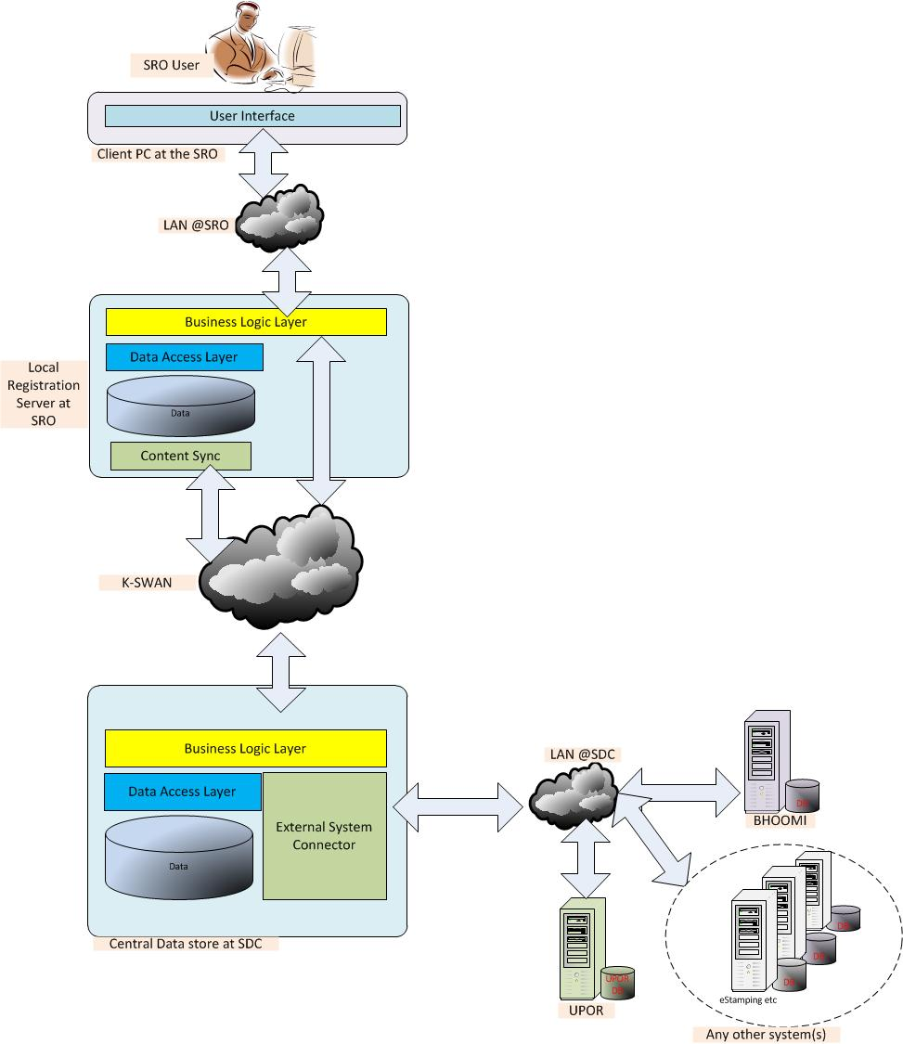

Hybrid Model

Deployment Plan:
The proposed deployment plan at each of the SROs and DROs is as displayed below:

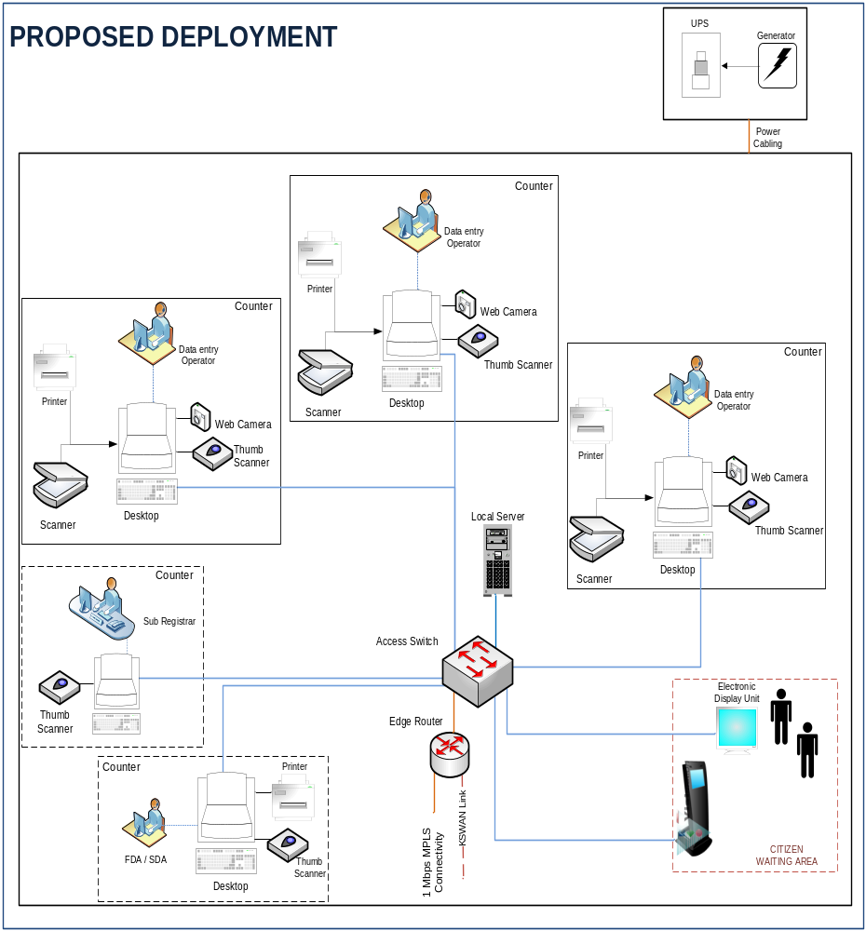

The proposed deployment plan at SDC is as displayed below:
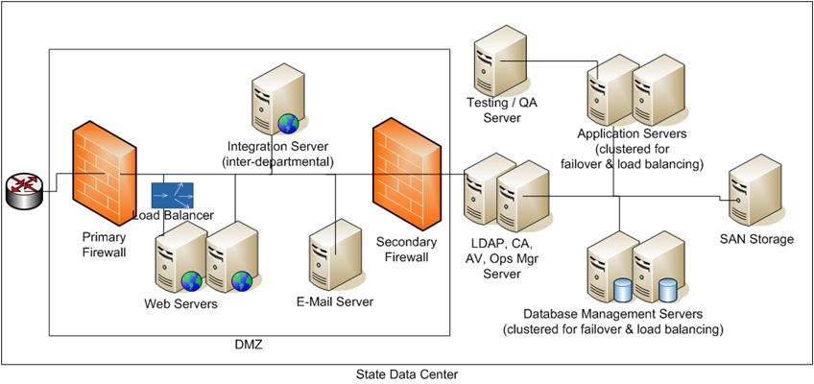

Functional Architecture & Requirements

Key Design Requirements

The sections below broadly outline the functional requirements of the New KAVERI application.

The following table highlights the overarching design requirements of the DS&R Project. The specific requirements of each of the core processes of the application are detailed in proceeding paragraphs.
No | Overarching Requirements | Description of the Functional Requirement
FRM 1 | Single Sign On (SSO) | - The Service Provider (SP) must design the Solution to enable single-sign-on so that any departmental user once authenticated and authorised by the system need not be re-authenticated for completing any of the services in the same session.  - Unique and secure identification of the business user is of utmost concern in the envisaged solution.  - Solution must be role-based and shall enable single-sign on facility to the applicable services, for which the user is enrolled/authorised.  - This provides the opportunity for introduction of digital signature certificates, which shall be used for authentication and authorisation.  - Terminal sessions should be protected by auto-locking.
FRM 2 | Security | The systems implemented for New KAVERI Project should be highly secure, considering that it is intended to handle sensitive information relating to citizens. The overarching security considerations are described below.  - The security services used to protect the DS&R System shall follow industry standard protocols  - The solution shall support advanced user authentication mechanisms, which includes, Biometric Authentication and Digital Certificates.  - Security design should provide for a well-designed identity management system, security of physical and digital assets, data and network security, backup and recovery and disaster recovery plan.  - The solution should provide for maintaining an audit trail of all the transactions.  - All sensitive transactions such as user logon to portal, online payment should be carried out over secure channel  - System should address the major security issues like:  - Invalidated input  - Broken Session Management  - SQL Injection  - Cross site scripting  - Caching issues  - Exception handling  The system should ensure that Web application security  - Guidelines as laid out by OWASP should be taken into account and followed to avoid any potential security breach
FRM 3 | Scalability | - One of the fundamental requirements of solution for the New KAVERI Project is its scalability.  - System should be scalable both horizontally and vertically to cater to future requirements  - The architecture should be proven to be scalable and capable of delivering high-performance as and when the number of users and transactions increase.  - The proposed solution should sustain the increased number of transactions in future.  - The expected amount of increase in the volume of transactions is about 25 % of the current volume. In order to avoid choking of the infrastructure, it is expected that the SP will make additional provisions so as to ensure that even after the growth of 25% of the volume of transactions the system capabilities are not utilized beyond 75% of the available capacity  - In this context, it is required that the application and deployment architecture should provide for Scale-Up and Scale out on the Application and Database Servers and all other solution components.
FRM 4 | User Administration | - System shall facilitate user security administration activities in terms of creation of user ids, user profiles, attaching the user profiles to the user ids, modification of user privileges etc.  - System shall have audit trails built in for all the activities performed by the super user/administrator in the system for user administration, database management, business rule changes, changes based on Registration Act and other governing Rules, system upgrades etc. Such audit trails, at a minimum, shall capture the details of name of the user, changes made, date of changes, name of approver (if applicable) etc.  - Password Management services must enforce password restrictions, which include the criteria and limitations that can be placed on passwords to increase security. It should provide features such as periodic forced changes, not reusable, hard to guess, mixed characters, etc.  - Successful user login requests should be logged for investigative purposes in case of a security breach  - The application must monitor unauthorised attempts to access the system  - The system should lockout an account after 5 successive unsuccessful attempts to login from the same account within a predetermined period.  - The system should automatically record the officiating officer information based on the login Id wherever required in all the transactions under various modules.  - The solution should be capable of secure, tamper proof auditing and logging which can stand in the court of law through implementation of advanced features.
FRM 5 | Workflow based approval | - System should facilitate workflow based approval wherein the transactions initiated can be approved both through internet/intranet by the approving authority and subsequently posted.  - Role-based access control should exist to ensure access to users on a need to know basis and to prevent unauthorised entries being made. System should not allow database/backend changes.  - All entries should require authorisation as defined by DS&R.  - The system should popup alerts during all phases of workflow approvals and should also provide an MIS for management to check the status of transactions at various levels within the workflow.  - The workflows should relate to the Roles and responsibilities of the officials doing the registration of documents.  - It should be able to generate online status update with regard to public transactions.  - Administration of user role and delegation of roles must be made possible in the workflow design.  - Services involving workflow and its illustrations are given in Annexure 4.
FRM 6 | Support for PKI based Authentication & Authorization | - System shall support PKI based Authentication & Authorization, in accordance with IT Act (with latest amendments), using the Digital Certificates issued by the Registration Authorities (RA) approved by Govt of Karnataka.  - PKI based authentication & authorization shall be implemented by SP for all officials/employees involved in the processing.
FRM 7 | e-Forms | - The e-forms created for delivering the DS&R services through the application or portal shall be designed keeping in view the bandwidth capacity so as to suit typical internet connections  - The form filling should be easy, user friendly and shall avoid common form filling errors (such as, ensuring all mandatory fields are entered, selecting options by checking boxes where applicable, number entry etc).  - Portal shall provide the printable formats for all the e-forms and user, upon filling up the details, can obtain the printout of the same (in pdf format, etc).  - Portal shall be developed in a manner so that it adheres to the standards specified for portal by Department of Information and Technology, Government of India.  - The government of Karnataka has envisaged the creation of State Service Delivery Gateway (SSDG). The State Service Delivery Gateway project has been formulated to fulfill the vision of providing easy and convenient services to the citizens through remote access primarily through Common Service Centres (CSCs) and enabling the State Portal (by implementing the key components State Portal viz. SSDG, electronic Form (“eForms”), Application and Computing Infrastructure). The department’s web portal has to integrate with state portal and SSDG so that services being offered using the portal can also be delivered using these platforms.  - All the e-forms shall have appropriate field level and form level business validations built into it to ensure that scope for incomplete/inaccurate information is eliminated and the information is captured for all the mandatory fields in the form.  - The e-Forms shall have appropriate formats for online(e.g html) and offline versions(e.g pdf) (that meet all the requirements described in this section)  - Users must also be able to download the e-Forms and fill them at their convenience, without requiring to be connected to the portal.  - The e-Form shall include validation functionality such that the user is able to verify whether information filled-in is complete, whether it includes all the mandatory information & attachments, and other validations which can be performed even without being connected to the portal (e.g. date & time validations, numeric vs. character data feed validation etc).  - During the e-Form upload in the portal, the portal shall perform the complete scrutiny and validation of the e-Form and its contents (e.g. validation of contents filled in the e-Form against the database, system checks etc).
FRM 8 | Business Rules | - All business rules shall be maintained centrally at the server level  - Modifications to the business rules and validations requests shall be approved by the designated authority of the DS&R  - A GUI based interface shall be provided to maintain and update Business Rules for various calculations  - System shall have audit logs for changes made in the business rules  - System will use standard codes to denote village, taluk, district, land type and others as will be specified by the department.
FRM 9 | Notification | - All notifications are to be sent through the workflow system along with provision for notifications to be sent in parallel through email and SMS.
FRM 10 | User Management | - The system should have a User Management module to implement the following:  - User creation  - Providing access control based on jurisdiction, roles and delegation of authority/roles.  - Workflow based routing and approval  - Audit trails  - Profile information capture as part of the login info
FRM10 | Bi-Lingual Requirements | - The software system so developed (input, storage , output) should have bilingual provision(Kannada & English) wherever required  - The system should be compliant with Unicode standard.  - Within Unicode UTF-8 shall be the preferred format when encoding option is available between UTF-8, UTF-16,UTF-32  - The e-Forms to be developed should be available in both English and Kannada. User is to be given the option of choosing the desired language for the purpose of filling up the form. The user should be able to key in the form details from keyborad in the chosen language. In case of online e-Forms the choice of language maybe given prior to filling up of the form. In case of offline e-Form the choice of language can be provided prior to the download of the e-Form  - Numerical values maybe kept out of the purview of bi-lingual requirements  - System should ensure that user input is possible in selected language only, i.e English e-Forms will not accept Kannada as input and Kannada e-Forms will not accept English as input.  - Service deliverables e.g certificates should be available in both English and Kannada as per business requirements  - The system shall provide default and master values in the e-Form in the language selected by the user  - The error messages thrown to the user by the system should be in the language selected by the user for filling up the form.

Functional Architecture
The diagram below outlines the functional view of the New KAVERI application. The detailed description of each module, process flow and other information of the various modules are given in the latter part of the section. The detailed process flow maps of functional modules are given in Annexure 2.
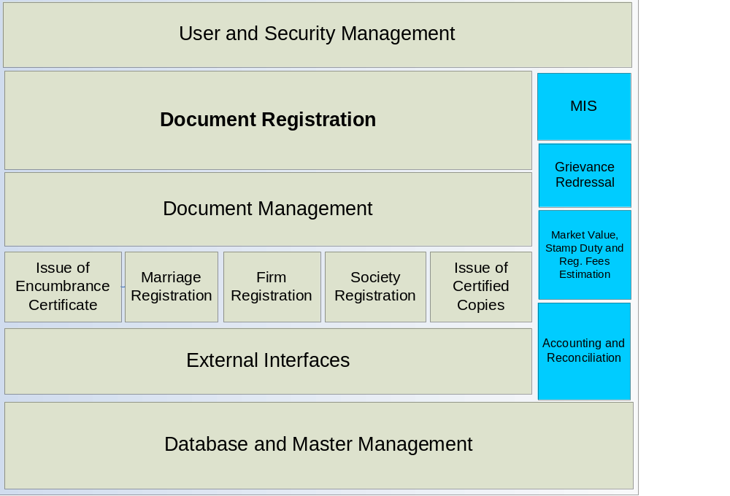 Figure 5: Overview of the Functional Architecture

The various components that shall be exposed to the citizen over the internet/BangaloreOne, Karnataka One/Nemmadi are as follows:
- Data Entry – This shall facilitate online basic data entry for the registration of documents, firms and marriages
- Scheduling of Appointments – This shall facilitate scheduling of appointments for registration of documents, firms, societies and marriages
- Encumbrance Certificate – This shall facilitate online application for Encumbrance Certificate and Online Encumbrance Search
- Certified Copies – This shall facilitate online application for certified copies.
- Market Valuation and Stamp Duty (SD) & Registration Fee (RF) estimation – This module shall facilitate calculation of Estimated Market Value for the property and also estimate the Stamp Duty and Registration Fee for registration of documents.
- Tracking of application status can also be done using the internet.
The following table describes the relations of services with various channels of delivery.
Sl. | Service | Inputs | Output | Channel
1 | Document Registration | - Document / Deed  - Stamp duty in the form of cash, DD, Bank Challans, e-Stamping  - Registration fees in form of cash, DD, Bank Challans | - Receipt  - Registered document  - Certified Copy | For data entry and appointment scheduling:  Portal/SRO/B1, K1/Nemmadi  For Registration, Payment and delivery of output:  SRO/DRO
2 | Marriage Registration | - Application in prescribed form  - Declaration (in case of Special Marriage)  - Memorandum of Marriages | - Marriage Certificate | For application and appointment scheduling:  Portal/SRO/B1, K1/Nemmadi/Post  For Registration, Payment and delivery of output:  SRO
3  a  b | Issue of Encumbrance Certificate  As Information  As Certificate | Form 22 duly filled by applicant  Form 22 duly filled by applicant | Encumbrance Records (Unsigned by SR)  Encumbrance Certificate (Signed by SR) | Both for application and Delivery:  Portal/B1, K1/Nemmadi/SRO  For application and Payment:  Portal/SRO/B1, K1/Nemmadi  For delivery of output:  SRO/Post/B1, K1/Nemmadi
4  a  b | Issue of Certified Copy  As Information  As Certificate | Form 22 duly filled by applicant  Form 22 duly filled by applicant | Document Copy (Unsigned)  Certified Copy (Signed by SR) | Both for application and Delivery:  Portal/B1, K1/Nemmadi/SRO  For application and Payment:  Portal/SRO/B1, K1/Nemmadi  For delivery of output:  SRO/Post/B1, K1/Nemmadi
5 | Firm Registration | - Application form for the service required  - Partnership deed copy  - Declaration duly attested | - Certificate of Registration of Firm  - Receipt / Acknowledgement | For data entry and appointment scheduling:  Portal/DRO/B1, K1/Nemmadi  For Registration, Payment and delivery of output:  DRO
6 | Society Registration | - Application form for the service required  - Partnership deed copy  - Declaration duly attested | - Certificate of Registration of society  - Receipt / Acknowledgement | For data entry and appointment scheduling:  Portal/DRO/B1, K1/Nemmadi  For Registration, Payment and delivery of output:  DRO
Table 8: Output, Input and delivery channels for various Citizen Services

List of Modules
This section details the list of modules to be provided in the Core KAVERI Application and functional requirements for each of them. The proposed process maps and detailed descriptions for individual modules/processes are provided in separately in this document.
No | Module Name
MOD 01 | Document Registration Module
MOD 02 | Marriage Registration Module
MOD 03 | Firm Registration Module
MOD 04 | Market Valuation, SD & RF Estimation Module
MOD 05 | Encumbrance Search Module
MOD 06 | Certified Copies Module
MOD 07 | Accounting Module
MOD 08 | Grievance Redressal Module
MOD 09 | Society Registration Module
Table 9: List of Modules

MOD 01: Document Registration
The system should estimate Estimated Market Value (EMV), stamp duty (SD) and Registration Fee (RF) and generate valuation slip on entry of required parameters.
The system should display EMV/SD estimation sheet on request by authorized users.
The system should accept service request at Kiosks in SRO and generate the service token with running serial number. The running serial number will be displayed on the operator’s system as well as electronic display board.
The system should log the service request to the SR in the system.
The system should display the application processing status both on department system as well as on portal.
The system should record application details. (Both through web portal as well as system running at SROs). The system should allow upload of e-Form for Registration filled up offline as well.
The system should notify status of the process to applicants through display on electronic board.
The system should display application on query.
The system should capture payment details. It should detect duplicate entries of payment through same instrument. It should generate and print receipt in duplicate for payment received. System should support integration with any third party payment gateway.
In case the parties decide to withdraw from the registration process before completion, the system should have the provision for recording the same.
The system should have the provision for mandatorily Recording reasons for refusal of documents by the SR for registration in case such a situation arises
The system should display the application details to the SR on his system for scrutiny. It should facilitate the SR scrutiny through appropriate user interface. It should display the checklist of various scrutiny and validations that SR is required to do in course of Registration. The system should record the scrutiny conducted and remarks thereby of the SR against each item in the checklist. The system should not enable further process unless all required checks are conducted by the SR and approved by him. All critical validations and approvals must be reaffirmed by the SR through his response to system generated alerts and messages before moving on to the next step in the process (Such Reaffirmations through system generated alerts is applicable wherever critical validations, authorizations and approvals are built in any process in the new Kaveri system.). The system must automatically and necessarily pop up the encumbrance certificate for at least last 13 years on screen of the SR before admission of the document.
The system should retrieve data from external databases of Bhoomi, SSLR, ULBs and IT department on providing appropriate input by the SR for validation of property schedule and identification of owner. Web services should be created to do such validation through the proposed application.
The system should retrieve e-Stamp payment detail from e-Stamp server for validation. Web services should be created to do such validation through the proposed application.
The system should capture thumb impression and photograph of parties. It shall record full address of witnesses. The system will match the thumb impression of the current seller against that of the buyer in previous encumbrance record pertaining to transfer of property under registration. It should pop up error message in case of mismatch.
The system should generate printable summary report based on the entered registration data in read only format with date, place and time stamp. The system should allow generation of printable summary report only on acknowledgement of both presenter and FDA/SDA through scanning of their thumb impressions and subsequent verifications with master in the system. On acknowledgement, system should automatically mail the read only summary report, with date, place and time stamp, to official e-mail id of the department (compulsory) as well as presenter’s e-mail id (optional) as provided in the form. The system should also maintain audit trail of the summary report for every registration process with date, place and time stamp along with editor’s name and official id.
The system should generate endorsement as per department’s format with Name of SR, time and date stamp. The system should maintain audit trail of the endorsement for every registration process. Printing of the registration Endorsement should be compact and as far as possible it should be printed on single sheet of paper. There shall not be any scope for keeping unnecessary gap in the sheet on which endorsement is printed.
The system should generate unique registration number ending with current financial year for a registration process if successfully completed and after authorization of SR through the system. The authorization by SR will require him to enter his thumb impression in the system which gets validated with master data storing his personal profile including the thumb impression and photograph. Once a registration number is generated the transaction details are locked for editing. It will require a special permission from the administrator to edit a registered data however through appropriate channel and authorization from department.
The system should enable scan and upload of registered document to the central server (both real time as well as in batch mode at set time periods). The document must be well indexed for easy storage, retrieval and management. When an amendment is made to a registered document through another registered document or filing (under Book 1 - part 1, 3, 4 and 5), a link should be established between the two documents in the system. Whenever an amended document is displayed or printed, the footnote should appear that ‘particular document is amended through another document with given reference number as the case may be’. (Such amendment provision is applicable for all kind of registered documents produced as an outcome of firm, marriage and document registration.)
The system should capture number of pages in the document to be registered and scanned. It should have built in control to ensure exact number of pages in the document to be scanned. It should generate alert in case number of pages scanned vary with original number entered and verified by SR. Similarly, exact number of pages of copy of a registered document must be printed whenever required. Else, error message must be generated. The number of prints and scans associated with a registration must be in direct tight-couple relation with number of registrations. All such prints and scans must be accounted and reconciled through the system on daily basis with the related inventory. (To be managed through Asset/Inventory management module, provided by separate vendor). Wastages, if any, must be accounted under separate head.
The system should also capture the Scanning Fee based on the number of pages scanned and generate the receipt accordingly through the accounting module.
The system should be able to consume data from Bhoomi, MOJINI, urban local bodies, Treasury and Income Tax databases and also transmit ‘J-slip’ (summary registration data in the form of xml) to Bhoomi database (in case of agricultural property) and Nirmal Nagar/Other ULB/UPOR or other appropriate database in case of non- agricultural property in the required standard formats.
The system should automatically enter respective transaction data into A-Register and appropriate books, index registers and other required registers as soon as a registration process is completed. System should generate a unique running serial number ending with the year for every entry made in the A-Register. (Every service or transactions at SROs are entered in the A-Register.)
The system should create index of registrations as prescribed for Index I and II. Additionally, it should create index of registrations based on jurisdictions.
The system should generate MIS reports based on data captured. There should be authorization mechanism for role based access to reports for generation and view.
The system should have the provision for calculating any fine / penalty that might be applicable based on relevant business rules and generate receipts for payment through the accounting module.
The delivery details of registered document must also be captured in the system after returning of original registered document to the concerned party. An acknowledgement form will be generated and printed through the system.

MOD 02: Marriage Registration
1. | The system should record application details. (Online through web as well as Offline at Marriage Office).
2 | The system should accept payment and captures payment detail.
3 | The system should have mechanism to validate furnished details with external databases (UID, Personal Identification, marriage registers, birth records)
4 | The system should allow modification/deletion of entered data before registration and after registration with orders from the MO
5 | The system should allow Approval/Rejection of application with mechanism for entering the mandatory remarks in the system and generation of endorsement against the same.
6 | The system should notify MO/FDA/Applicants if application is rejected through e-mail, SMS, notification or endorsement.
7 | The system should record notice of intended marriage in the system both online and offline.
8 | The system should Display the notice on public portal after authorization of the MO in the system.
9 | The system should generate marriage certificate
10 | The system should capture delivery details once the certificate is issued.
11 | The system should show status of application.
12 | The system should display the application filed for editing by the applicant before registration.
13 | The system should display marriage records on query.
14 | The system should display available date and time for solemnization in case of special marriage.
15 | The system should book a slot for solemnization on request.
17 | The system should capture photographs of couple.
18 | The system should generate MIS reports based on data captured in the system. There should be authorization mechanism for role based access to reports for generation and view.
19 | The system should generate Summary Report for verification of data entered and make provision for correction if any changes found.

MOD 03: Firm Registration / Amendment / Dissolution
1 | The system should record application details. (Online through web as well as Offline at DRO).
2 | The system should Search Firms name and address in its database and give alert if firm with same name as applied for exists. It should not allow registration with existing name and address. The online application form will have the mechanism for the applicant to check for Firms’ names that are not feasible.
3 | The system should calculate Firm registration Fee on basis of department’s business rules.
4 | The system should print Acknowledgement and Fee Receipt on updating of payment details in the system.
5 | The system should generate unique Firm Registration Number once the registration process is completed. The authorization by DR will require him to enter his thumb impression in the system which gets validated with master data storing his personal profile including the thumb impression and photograph.
6 | The system should enable updating in register of firms and it’s Index in case of request for amendment / dissolution.
7 | The system should enable printing of respective endorsements and certificate based on application type whether registration, amendment or dissolution of Firm.
8 | The system should enable scan and upload of the documents attached with the application.
9 | The system should make automatic accounting entry for each transaction in A-Register
10 | The system should generate MIS reports based on data captured in the system. There should be authorization mechanism for role based access to reports for generation and view.
11 | The system should generate Summary Report for verification of data entered and make provision for correction if any changes found before registration.
12 | The system should also allow filing of documents/information like returns, etc both through web portal as well as offline at DRO.

MOD 04: Market Valuation and Stamp Duty Estimation
1 | The system should fetch survey map from SSLR database on basis of entered property details.
2 | The system should fetch Record of Rights from Bhoomi as well as proposed UPOR database on basis of entered property details.
3 | The system should fetch guidance value from department database for selected location.
4 | The system should Estimate EMV based on guidance value and other parameters declared by the citizen in the online form.
5 | The system should display Questionnaire as online form for classification of document.
6 | The system should capture user responses for classification
7 | The system should classify automatically based on user responses
8 | The system should estimate SD and RF on basis of classification
9 | The system should generate Guidance slip based on estimations.
10 | The system should accept payment online if fees is prescribed for the information service
11 | The system should record transaction in A Register
12 | The system should generate MIS reports based on data captured in the system. There should be authorization mechanism for role based access to reports for generation and view.

MOD 05: Issue of Encumbrance Certificate (EC)
1 | The system should record EC application details. (Online through web as well as Offline at SRO). The application can be made for information EC which has to be processed instantly through the system search else the application for authenticated EC can be filed through the system. The system should generate application number and log an entry in the view list of concerned SR.
2 | The system should be able to search Index-II database on basis of one or more property identification parameters for generating relevant encumbrance records. The system will maintain index II records for the period where information is available in digital format. The search option should be available both on the intranet as well as the internet.
3 | The system should be able to calculate and collect the fees required for the service on basis of search period. It should generate receipt against the payment.
4 | The system should display the relevant encumbrance records for specified period with an option to the applicant to select one or more entries in the displayed list. On basis of the selection, the system generates EC in the specific format of the department.
5 | The system should allow save / print of generated EC.
6 | The system should automatically make an accounting entry for each fees receipt in A-Register for the service provided.
7 | The system should generate MIS reports based on data captured in the system. There should be authorization mechanism for role based access to reports for generation and view.
8 | The system should have built in authorization by SR through digital signature before generation of authenticated EC.
9 | The system should be able to generate intimation for the applicant through email/sms/notice.
10 | The system should accept service request at Kiosks in SRO and generate the service token for direct applicants at SRO.

MOD 06: Issue of Certified Copy (CC)
1 | The system should accept service request at Kiosks in SRO and generate the service token.
2 | The system should log the service requests to the SR in the system for both online and direct applicants.
3 | The system should display the application processing status on electronic display board (for direct applicants) and on portal (for online applicants).
4 | The system should record application (Online as well as that manually entered)
5 | The system should calculates fee and postal charges for postal mode of delivery
6 | The system should capture payment details in A-Register in the system.
7 | The system should generate receipt for payment received.
8 | The system should search and retrieve copy of the required document from the central server.
9 | The system should print copy only on confirmation of payment receipt. It should notify applicants through email/sms (for online applicants) /display on electronic board (for direct applicants).
10 | The system should captures delivery details of the certified copy.
11 | The system should enable authorization through digital signature of SR on the retrieved copy which can be accessed at point of request such as Portal/B1, K1/Nemmadi. The system should also allow digital signing of the registered documents for future use so that digitally signed documents are available on the server for remote access and download.
12 | The system should automatically make an accounting entry for each fees receipt for the service provided.
13 | The system should generate MIS reports based on data captured in the system. There should be authorization mechanism for role based access to reports for generation and view.

MOD 07: Accounting
1 | The system should Post Entry in A-Register whenever a transaction occurs at SRO or through Portal. The transaction status must be recorded in the system. It should record various modes and channels of payments.
2 | The system should generate Remittance Register on basis of the collections made. The system should be able to segregate the revenue collected on basis of detailed head of accounts, mode of payment etc. specified by the department.
3 | The system should generate and print challans in pre-defined format for deposit in agency Bank. The system should generate alerts if a recorded payment is not remitted through a challan.
4 | The system should facilitate entry of bank acknowledgement details such as scroll voucher number, date of realization etc. corresponding to a challan.
5 | The system should ensure remittance tracking using Challan Number, Token No and Bank Scroll Voucher Number.
6 | The system should allow preparation of Account Statement on basis of transaction data recorded in the system.
7 | The system should generate MIS reports based on data captured in the system. There should be authorization mechanism for role based access to reports for generation and view.
8 | The system should reconcile the remittances with the KTC 25 form issued by treasury and in case of discrepancy issue alerts.

MOD 08: Grievance Redressal
1 | The system should record grievance redressal application both through intranet at SRO/DRO as well as through internet via the portal.
2 | The system should route application to corresponding officer based on type of grievance. It should be escalated to appropriate authority based on department business rules and escalation matrix.
3 | The system should display status of the application at processing stages.
4 | In case of inaction beyond certain period, the system should generate alerts.
5 | The system should record the responses of the addressing officers with appropriate time stamp and audit trail mechanism. The application and responses must be retrievable for post-facto audit if needed.
6 | The System must generate unique identification number for each of the grievances.
7 | The system should generate MIS reports based on data captured in the system. There should be authorization mechanism for role based access to reports for generation and view.

MOD 09: Society Registration / Amendment / Dissolution
The system should record application details. (Online through web portal as well as Offline at DRO).
The system should search Society name and address in its database and give alert if society with same name as applied for exists. It should not allow registration with existing name and address. The online application form will have the mechanism for the applicant to check for Societies’ names that are not feasible.
The system should calculate Society registration Fee on basis of department’s business rules.
The system should print Acknowledgement and Fee Receipt on up-dation of payment details in the system.
The system should generate unique Society Registration Number once the registration process is completed. The authorization by DR will require him to enter his thumb impression in the system which gets validated with master data storing his personal profile including the thumb impression and photograph.
The system should enable updation in register of societies and it’s Index in case of request for amendment / dissolution.
The system should enable printing of respective endorsements and certificate based on application type whether registration, amendment or dissolution of Society.
The system should also allow filing of documents/information like returns, etc both through web portal as well as offline at DRO.

Detailed Functional Requirements
This section details the functional requirements for each of the modules listed in the table above and DS&R has made all possible efforts to ensure that the requirements are captured completely. However, there could be few changes (both additions and deletions) to the stated requirements and final functional and system requirements specifications shall be signed-off between the DS&R and the SP prior to commencement of the system development and at the time of approval of SRS. In the initial stages of implementation, department may need to issue requests for some changes and small enhancements despite the sign-off of SRS document. The SP shall cater to such change requests till Go-live stage with no additional cost.

MOD 01 - Document Registration Module
Functional Requirement Specifications
Stakeholder/ Interface | Role/ Responsibilities
Applicant | - Obtains the correct EMV , SD and RF by self through online EMV/SD/RF estimation module on portal  - Submits the application along with the e-Form and other required details through the portal, makes the payment for appointment fee through the payment gateway and books an appointment in the chosen SRO for registration. He makes a service request in the Kiosk if he avails the service in person at SRO. He has the option to apply in person or online or at BangaloreOne, Karnataka One/Nemmadi centres as well.  - Furnishes the document for registration along with required attachments at SR/DR office.  - The applicant obtains appointment using the portal or BangaloreOne, Karnataka One  - Presents the document with required testimonials to the SR along with witnesses.  - Makes the payment of stamp duty and registration fees. If he has paid the stamp duty through Challans or e-Stamp, he produces the proof for same.  - Signs the summary report, the endorsement, Form 60 - 61, and 81 A declarations.  - Collects the original signed and sealed copy of the registered document, endorsement and the print out of the scanned document from the system and also the Encumbrance Certificate of the Transaction
Operator /FDA/SDA | - FDA/SDA/Operator does preliminary verification of document and enclosures. If application is incomplete or incorrect, he refuses the document with proper entries of reasons in system.  - FDA/SDA/Operator will enter the application data in system, once directed by the SR, if it is not submitted online.  - He captures photographs and thumb impressions of the parties.  - Prints summary report and copy of scanned document  - Scans the registered document and other relevant documents to be saved along with the registered document.  - Digitally signs the scanned copy of the registered document along with the other scanned documents to be stored for future reference  - Stores the application and other testimonials in SRO
SR | - Verifies the applications and requests made online/ in person.  - Directs the FDA/SDA/Operator to enter the application data in the system for applicants in the SRO. The same can be done by SR himself if he so desires.  - Examines the document and the testimonials.  - Checks appropriate classification of document.  - Confirms correctness of EMV, SD and RF.  - Collects stamp duty and registration fees and updates payment detail. In case of payment of Stamp duty through e-Stamping, the SR will validate the same by entering unique e-Stamp number in the system and fetching the payment detail from e-Stamp server.  - Confirms valid presentation of the document, voluntary execution of deed and admission of execution by parties and party identity by the witnesses  - Verifies the correctness of the photos, thumb impressions of the parties and witnesses, affixed on to the document and registration endorsement, before check and registration of the document.  - Admits/refuses document for registration.  - Records reasons in ‘Book II’ to be maintained in the system, in case the document is refused.  - Records reasons in ‘Minute Book’ to be maintained in the system, if the document is kept pending.  - Registers the document through system.  - Signs summary report, registration endorsement and the registration certificate.  - Digitally signs the scanned copy of the registered document which is stored in the system.  - Returns the registered document to the concerned party after obtaining signed acknowledgement.
System | - Generates and Displays Estimated Market Value/ valuation slip, stamp duty/Registration Fee.  - Accepts required information through e-forms in the portal.  - Uploads filled up e-Forms  - Provides payment gateway to pay Appointment Fee  - Shows the available slots for appointment in each SRO and allows for booking of appointments.  - Sends the confirmation details of appointment booked through SMS/e-mail etc.  - Accepts service request at Kiosks in SRO and generates the service token  - Logs the requests to the SR in the system  - Displays the application processing status on electronic display board  - Records application (Online as well as manually entered)  - Notifies Applicants through display on electronic board  - Shows status of application offline/online  - Sends notification through SMS/e-mail on incomplete or incorrect application, cancellation of appointment due to disruptions in service, etc.  - Displays application on query  - Captures payment detail  - Generates receipt for payment received, summary report, unique registration number/Refusal number/pending number/Withdrawal number and endorsement  - Captures document delivery details  - Print, Scan and Store Form 60,61, 81-A, Affidavit, Form - 1.  - Retrieve data from external databases of Bhoomi, SSLR, ULB’s and Income Tax department  - Retrieve e-Stamp payment detail from e-Stamp server  - Enter transaction into A Register and appropriate books and index register.  - Transmits J-slip to Bhoomi application of the Revenue Department hosted in State Data Centre (SDC) for agricultural property
Process Triggers | - Application online  - Request for service in Kiosk when applied in person in SRO  - Application online at B1, K1/Nemmadi centres
Process Flow | Document Registration – Online Application  - The applicant will be able to register on the portal with login/password and some basic information including e-mail etc, or use a guest login to initiate any form of application.  - The applicant will be allowed to save incomplete applications and access them again through the portal using their login and password and complete the application within a time period.  - The applicant logs on to the service delivery portal of the department. He selects the service “Document Registration” from the list of available services. He selects from the list, the SRO in whose jurisdiction the property belongs as well as the SRO where he wants to register the document. The online e-Form for entering the data is displayed. The instruction to fill the application online is available on the page.  - The online form will have separate tabs for entering different information type such as Personal detail of parties and witnesses, document details, property details and schedules. The applicant fills up the form and submits online.  - The system will validate the application. If the application is invalid or incomplete, or the land is barred from registration as per data received from Bhoomi (Govt land, granted land, etc) system will reject application (before initiating process for booking appointment) and notify the reason through a pop-up message giving the option to the applicant to modify application or exit. If the applicant wants to modify the application, he is redirected to the online form for resubmission. Else he will save/print the “notification for rejection” and exit.  - In case the property to be registered is agricultural the system will retrieve the details of seller name (present owner), extent, etc from Bhoomi database in the backend and display it to the applicant for confirmation. After confirmation the details will be auto populated in the e-forms.  - The applicant can check available time slots in the relevant SROs on the portal and opt for suitable date, time and SRO available for appointment.  - The applicant will then have to pay the required Appointment Fee through the payment gateway provided in the portal for confirmation of appointment.  - Upon confirmation the system displays the details of the Appointment and a unique appointment code for printing. The appointment details will also be sent through sms/e-mail.  - The citizen can obtain Estimated Market Value, stamp duty and registration fee online before or while filing an application.  - The SR will log on to the system in the SRO. He will find the list of online applications logged to his screen scheduled for the particular day. The parties will visit the SR on specified time and date. They will enter the application number/appointment code in the Kiosk at SRO and mark their presence for presentation of document. The SR will call the parties to present the document on scheduled time. The parties will present to the SR with the documents and required enclosures.  - The SR using a checklist prompted by the system will do the following checks:  - Date of execution and presentation of the deed  - Admission by parties for voluntary execution of the deed  - Classification of the document  - Property locations and schedules mentioned in the deed  - Check for any Court Orders related to the said property as indicated by the Court Order Module.  - Verify Estimated Market Value and stamp duty for the given property details (which must be same as mentioned in deed)  - Validate payment in case of e-Stamping from the SHCIL server  - Validation of the testimonials – RTC, Khata, PAN, Revenue sketch, affidavit and Form 1  - Verify Data entered in the system vis-à-vis the physical documents and testimonials  - Check for impersonation by matching of thumb records/photograph (current seller with previous buyer in index II record).  - The system should also be able to integrate with Aadhar system (developed by Unique Identification Authority of India - UIDAI) and interface with it to utilize authentication services/APIs provided by the Aadhar system wherein the biometric/thumb impression captured in the New Kaveri system is sent securely to the Aadhar system and the authentication information is received back for verification. (The details of the requirements for the New Kaveri application to integrate with the Aadhar/UID system are provided in Annexure 4 of this document).  - Checks for duplicate and multiple registration done through index II validation online for the same schedule of property  - Check if the property is banned from registration by law or court order by checking the information provided by the Court Order Entry Module.  - The SR will also validate the data furnished in RTC, survey sketches, Khata and PAN through online access of databases of Bhoomi, SSLR, concerned ULB and IT department. (However, this integration is subject to readiness of the databases of concerned departments. The system should have the feature to validate the document with these external databases whenever they are made available.)  - On complete validation, the SR will admit the document for registration and ask the parties to pay the stamp duty and registration fees. The payment details are entered in A-Register in the system by SR and the generated receipt is given to the presenters. The buyer signs the Form 60/61 and Form 81-A as applicable and submits it to SRO. SR asks the FDA/SDA/operator to capture photograph and thumb impression of the parties.  - The SR will not accept/admit the document for registration in following scenarios:  In case:  - The document is refused for registration as the SR finds it barred from registration after his Scrutiny. An entry is made in book 2 as reason for refusal. He endorses the word “Registration Refused” on the document. On application made by executants or claimants, SR gives him a copy of the reason so recorded without any payment. The entry is also made in the minute book. In case of refusal to accept the document, the system shall generate the refusal number and mandatorily record the reason for refusal in the system. The SR shall record presentation and endorsement.  - In case of refusal to admit the document is kept pending as it deviates from normal registration. System generates a unique pending number along with the entry of reasons for pendency in the minute book.  - The document shall be impounded/kept pending if the presenter does not pay the stamp duty payable as per the Karnataka Stamp Act 1957/ estimated by SR respectively. In case of undervaluation, SR makes an entry in the undervaluation register (Register of Section 45A) and keeps the document pending. System generates a pending number along with the entry of reasons for pendency in the minute book. In that case the valuation endorsement slip is given to the presenter and the case is referred to the concerned DR for determination of the proper Market Value.  - In case the presenter withdraws the document before final registration, except in case of impounded documents kept pending, the request may be honoured by making an entry in the withdrawal register. (Unless proper stamp duty and penalty is paid, impounded documents are not returned)  System will have the provision to enable all such functionalities.  - The FDA/SDA/operator captures the thumb impression (through scanner) and photograph (through webcam) in the system. The SR then generates the summary report and asks the parties to verify the data contained in it. If any valid error is pointed, SR will check and make necessary corrections in the system. The corrected summary report is again printed by SR and shown to the parties. On affirmation of the parties and upon SR’s own satisfaction, the summary report is signed by both the parties and the SR. It is also signed by the FDA/SDA/operator. As directed by SR, FDA/SDA/operator prints the endorsement and give to the parties to verify and sign it. Parties and witnesses sign the endorsement in front of the SR. The SR also signs the endorsement and puts his office seal.  - The SR completes the registration in the system by authenticating using both his digital signature and thumb impression which shall be matched against the database. A unique registration number is generated in the system. An entry is made in the A Register by the system. Index I, Index II Index III and Index IV records (as the case may be) are also populated with registration data. The endorsement signed and sealed by the SR is attached with the document and then sent for scanning.  The scanned document is stored locally on the basis of book type, date of registration and location of property. The print out of scanned document along with entry of the registered document in the form of EC is also given to the party along with the original document. The Index data shall be pushed to the central server at SDC on a real time basis. The scanned images are digitally signed by the SR and pushed to the central server on periodic basis as applicable. (End of Day, twice a day, etc) Scanned supporting documents can be moved to tape backup or other permanent storage devices and stored in a separate directory structure with proper naming and indexing conventions. They should be accessible through the Document Management System whenever required.  - J Forms are forwarded to the Bhoomi application hosted in the SDC in case of registered documents related to agricultural land and acknowledgement from Bhoomi system is obtained as a response and stored for future reference.  Document Registration – Apply in Person  - The applicant visits the SRO and opts for the service in Kiosk. He selects the service “Document Registration” from the list of available services. He selects from the list, the SRO in whose jurisdiction the property belongs in case the office visited is not the one where property belongs. The service request is generated and forwarded to the SR. service token is printed at Kiosk printer and retained by the presenter.  - SR forwards the request to SR/FDA/SDA through the system for preliminary verification of the documents and data entry. Parties are asked to approach SR/FDA/SDA through message flashed on electronic display. Parties approach SR/FDA/SDA and submit all documents. SR/FDA/SDA will examine the deed, date of execution and other testimonials. On being satisfied, operator enters the details of document, parties, property, witnesses in the system. The application is then forwarded to the SR through the system.  - The SR will call the parties to present the document on scheduled time through electronic display message. The parties will approach SR on being called with the deed, payment of stamp duty and registration fees, witnesses, and required testimonials and affidavit.  - The SR will do the following checks:  - Date of execution and presentation of the deed  - Admission by parties for voluntary execution of the deed  - Classification of the document  - Property locations and schedules mentioned in the deed  - Check for any Court Orders related to the said property as indicated by the Court Order Module.  - Verify Estimated Market Value and stamp duty for the given property details (which must be same as mentioned in deed)  - Validate payment in case of e-Stamping from the SHCIL server  - Validation of the testimonials – RTC, Khata, PAN, Revenue sketch, affidavit and Form 1  - Verify Data entered in the system vis-à-vis the physical documents and testimonials  - Check for impersonation by matching of thumb records/photograph (current seller with previous buyer in index II record).  - The system should also be able to integrate with Aadhar system (developed by Unique Identification Authority of India - UIDAI) and interface with it to utilize authentication services/APIs provided by the Aadhar system wherein the biometric/thumb impression captured in the New Kaveri system is sent securely to the Aadhar system and the authentication information is received back for verification. (The details of the requirements for the New Kaveri application to integrate with the Aadhar/UID system are provided in Annexure 4 of this document).  - Checks for duplicate and multiple registration done through index II validation online for the same schedule of property  - Check if the property is banned from registration by law or court order by checking the information provided by the Court Order Entry Module.  - The SR will also validate the data furnished in RTC, survey sketches, Khata and PAN through online access of databases of Bhoomi, SSLR, concerned ULB and IT department. (However, this integration is subject to readiness of the databases of concerned departments. The system should have the feature to validate the document with these external databases whenever they are made available.)  SR confirms and records these checks, conducted during scrutiny of document, in the software system. In case of alteration, remarks are posted by him against the corresponding checks.  - On satisfactory check, the SR will admit the document for registration and ask the parties to pay the stamp duty and registration fees. The payment details are entered in the system by SR and the generated receipt is given to the presenter. The buyer signs the Form 60/61, in case PAN is not available, and Form 81-A as applicable and submits it to SRO. SR asks the FDA/SDA/operator to capture photograph and thumb impression of the parties.  - The SR will not admit the document for registration in following scenarios:  - The document is refused for registration as the SR finds it barred from registration after his Scrutiny. An entry is made in book 2 as reason for refusal. He endorses the word “Registration Refused” on the document. On application made by executants or claimants, SR gives him a copy of the reason so recorded without any payment. The entry is also made in the minute book. In case of refusal to accept the document, the system shall generate the refusal number and mandatorily record the reason for refusal in the system. The SR shall record presentation and endorsement.  - In case of refusal to admit the document is kept pending as it deviates from normal registration. System generates a unique pending number along with the entry of reasons for pendency in the minute book.  - The document shall be impounded/kept pending if the presenter does not pay the stamp duty payable as per the Karnataka Stamp Act 1957/ estimated by SR respectively. In case of undervaluation, SR makes an entry in the undervaluation register (Register of Section 45A) and keeps the document pending. System generates a pending number along with the entry of reasons for pendency in the minute book. In that case the valuation endorsement slip is given to the presenter and the case is referred to the concerned DR for determination of the proper Market Value.  - In case the presenter withdraws the document before final registration, except in case of impounded documents kept pending, the request may be honoured by making an entry in the withdrawal register. (Unless proper stamp duty and penalty is paid, impounded documents are not returned)  System will have the provision to enable all such functionalities.  - The FDA/SDA/operator captures the thumb impression (through scanner) and photograph (through webcam) in the system. The SR generates the summary report and asks the parties to verify the data contained in it. If any valid error is pointed, SR will check and make necessary corrections in the system. The corrected summary report is again printed by SR and shown to the parties. On affirmation of the parties and after getting signatures and upon SR’s own satisfaction, the summary report is signed by the claimant and the SR. It is also signed by the FDA/SDA/operator. As directed by SR, FDA/SDA/operator prints the registration endorsement and gives to the parties to verify and sign it. Parties and witnesses sign the endorsement in front of the SR. The SR also signs the endorsement with date and put his office seal.  - The SR completes the registration in the system by authenticating using both his digital signature and his thumb impression which shall be matched against the database and a unique registration number is generated in the system. An entry is made in the A Register by the system. Index I and II records are also generated/ populated with registration data. The endorsement is signed by the SR and seal is affixed with the document. After final check by the SR, the Section 60 certificate is signed by SR & Round Seal affixed and then sent for scanning. The print out of scanned document and encumbrance entry is also given to the citizen along with the original document.  The scanned document is stored locally on the basis of book type, date of registration and location of property. The Index data shall be pushed to the central server at SDC on a real time basis. The scanned images are digitally signed by the SR and pushed to the central server on periodic basis as applicable. (End of Day, twice a day, etc) Scanned supporting documents should be moved to tape backup and not stored in system or database.  - J Forms are forwarded to the Bhoomi application hosted in the SDC in case of registered documents related to agricultural land and acknowledgement from Bhoomi system is obtained as a response and stored for future reference.
Data/ Information requirements | - Executed document drafted by self, deed writer or advocates; may be hand written or typed  - Stamp duty in the form of cash, DD, Bank Challans, e-Stamping  - Registration fees in form of cash, DD, Bank Challans  Enclosures –  - RTC (in case of Agricultural land)  - Khatha Certificate/Khatha Extract/Tax Paid Receipts (issued by the Local Bodies in case of sites/buildings)  - Form 60/61 in case PAN is not available, as per IT Act  - Affidavit signed by the executants in case of agricultural land  - 81 – A declaration  - 11-e Sketch of the agricultural property whose transaction is being effected  - Form - 1 (Rule-3 of Karnataka Stamp Act – Prevention of Undervaluation etc, Rules 1977) detailing the schedule description of the property.  - Database of thumb register of the department officials
Alternate Scenario 1 | Network (Both KSWAN and Alternate Network) Link is down
- Status of revised service availability and time slot is updated on central server based on severity of the breakdown
- SMS/e-mail is automatically triggered (Phone call through help-desk) to the applicants who had prior appointments with appropriate direction based on expected down-time
- Option to Register with pending status
- Option to re-schedule the appointment
- Option to register at other SROs
- Message is flashed on electronic display board at the public waiting area
- System will switch to offline mode
- Limited Functionality Application (LFA) will be operated by the SR with a temporary file storage system with back up option
- Application data will be entered by FDA/SDA as the case may be. (Through LFA)
- SR will do the scrutiny with following checks –
- Date of execution of the deed
- Admission by parties for voluntary execution of the deed
- Classification of the document (Through LFA)
- Property locations and schedules mentioned in the deed
- Market valuation, stamp duty and registration fee estimation for the given property details same as in deed (Through LFA)
- Data entered in the system vis-à-vis the physical documents and testimonials
- Manual examination of the testimonials – RTC, Khata, revenue sketch, affidavit and Form 1
- SR does the required scrutiny and updates the LFA system.
- Other activities such as payment updating, receipt generation, Summary Report and endorsements, their signing and capturing of photo and thumb impression is completed. (Through LFA)
- Pending Registration number is generated
- The registration data are stored locally till KSWAN is up. (Scanned document, Image, others as specified by department)
- The locally stored data are transmitted to the central server and synchronized with the database when KSWAN link is restored subject to following checks done successfully.
- Validate payment in case of e-Stamping from the corresponding server
- Check if the property is barred under law for registration by law or court order
- Check for impersonation by matching of thumb records (current seller with previous buyer in index II record)
- Checks for duplicate and multiple registration done through index II validation online
- The SR will also validate the data furnished in RTC, survey sketches, Khata and PAN through online access of databases of respective departments. (However, this integration is subject to readiness of the databases of concerned departments. The system will have the feature to validate the document with these external databases whenever they are made available.)
- Registration number is generated against the pending number
- Parties are intimated through e-mail / SMS and directed to collect the registered document with permanent registration number.
Alternate Scenario 2 | SR is not available for service
- The SR hands over the charge to FDA/SDA through intimation to concerned DR
- The DR will also have the right to delegate authority of SR to FDA/SDA on his own in case SR is not available for delegating.
- In the system, the SR initiates a request for handover to concerned FDA/SDA for specific period.
- The request is triggered to concerned DR (with copy to HO) and approved by him or approval can be given by the concerned SR himself
- Once approved, the system provides access of views authorized to the delegating SR to the concerned FDA/SDA for that particular office.
- System maintains audit trail of the hand over with time-stamp.
- Office charge is handed over to FDA/SDA. The role of FDA/SDA shall be temporarily changed to that of SR for authentication and registration purpose and shall be reverted back to the original upon return of SR.
Alternate Scenario 3 | Citizen does not appear for Registration on scheduled slot
- The slot is given to the willing applicants available in person at SRO
- The online application fee is forfeited
Alternate Scenario 4 | Previously registered document is modified/cancelled by a subsequent document (Rule 123 of the KR Rules 1965)
- The subsequent document will follow the same process of registration as that followed for normal registration.
- A cross-reference or link shall be established through the system between the amending/cancelling document and the amended/cancelled document.
- Whenever a linked document is viewed or printed, the system shall display/print the information that the said document is amended/cancelled by the referred document having the specified document number and vice-versa.
- Such links must also be established through the system in Index II table. Whenever, the linked document in index II is referred for encumbrance information, the reference to amending/cancelling document and vice-versa must also appear in the search result.
Alternate Scenario 5 | Document is presented after due date but before eight months (due date is within 4 months from date of execution) (Section 25 of Registration Act 1908, read with Rule 52 of the Karnataka Registration Rules 1965)
- The document presented after due date but within eight months of date of execution will follow the same process of registration as that followed for normal registration.
- The system should be able to determine the delay period and the corresponding condonation fee (fine) as per Rule 52 of Karnataka Registration (KR) Rules, 1965.
- The presenter has to file a separate application with reasons in compliance with Section 25 of the Registration Act 1908 for such delayed presentation, along with prescribed delay condonation fees and the document is kept pending till delay condoned by DR.
- The system should not allow the registration of the document without the payment of the applicable delay condonation fine and the appropriate order of the DR condoning the delay. The order of delay condonation given by the DR must be scanned and linked to the document in the system during registration.
- The system must have provision to admit the document presented on such delay with acceptance of the delay condonation fees.
- The document presented after eight months of execution should not be admitted for registration.
- Delay in Presentation shall not apply to Wills.
Alternate Scenario 6 | Denoting Stamp Duty on previously registered document as per Sec 16 of KSA 1957
- The document presented will follow the same process of registration as that followed for normal registration.
- The party should produce the original document for denoting duty
- If the stamp duty has been paid earlier for a previous document (either registered or unregistered) between the same parties for same transaction being registered now, the stamp duty paid on earlier document has to be denoted on to the current document.
- Endorsement of denoting
- The system should establish link between the two registered documents if the previous document is registered. The Accounting module should record the denotation (reduced payment of stamp duty) in the current registration for reconciliation.
- If the previous document is unregistered or registered before implementation of Kaveri application (before computerization) it should be scanned and stored in the system with the document being registered now.
- The system should be able to prepare a report of all such transactions along with the various documents and fees involved with denotation so that the same can be reviewed/audited by the concerned.
Alternate Scenario 7 | Power of Attorney Holder presents a document on behalf of the principal for registration.
- The SR should mandatorily obtain the authenticated / attested Special Power of Attorney for filing in the office. The same will also be scanned and stored in the system with link to the document to be registered.
- In case of authenticated/attested General Power of Attorney, copy of the same should be submitted to the SR for filing in the office. The same will also be scanned and stored in the system with link to the document to be registered if the GPA is not registered. If the GPA is already registered the document number is used to link the GPA to the present registration.
- Entry shall be made in the Power of Attorney Register with respect to the presentation of the document on the basis of the authenticated / attested Special/General Power of Attorney as the case may be.
- The document presented will follow the same process of registration as that followed for normal registration.
- The endorsement will record in the details of the presenter that the document was presented on behalf of the principal by the PoA holder.
- The power of attorney details are entered in the system and the scanned copy is uploaded along with the main document
- The system enables the SR to view the power of attorney register for any SRO in the state.
Alternate Scenario 8 | Registration of executed Will after death of the Testator
- SR should endorse the presentation endorsement on to the document.
- SR keeps the presented Will pending for registration after entering the data in the system and generating the Pending number.
- SR does the enquiry and records the witness statement.
- SR makes note of the findings and records it in the system.
- If he decides to register the Will, he records the enquiry proceedings on the registration endorsement and registers as usual.
- Else, he records the refusal endorsement after the enquiry proceedings endorsement and refuses the registration as usual.
Alternate Scenario 9 | Private attendance in case of parties being unable to register at SRO.
- The party or representative should be able to apply for ‘Private Attendance’ through the online portal (or other means like in person at SRO) along with the payment of the prescribed private attendance fee.
- SR should be able to capture the details (thumb impression, photo, etc) through offline system on his laptop by visiting the party at their place.
- SR will do the manual scrutiny on the spot.
- SR will follow the pending registration process and generate a pending number for the transaction.
- Back in SRO, SR will upload data on the central system and run the validation checks after capturing all the other required details from other parties who will visit the SRO and carry out the processes as per normal registration.
- On successful validation, a final registration number is generated and the parties are intimated through e-mail/sms/notice to collect the registered document.
- The final document is scanned and uploaded on the system as per normal registration processes.
Alternate Scenario 10 | Issue of commission for private attendance of the executant in area of jurisdiction outside the SRO where the document is presented.
- SR generates a commission through the system which is issued to the SR of concerned jurisdiction where the party is attended. The document is also sent to the concerned SR.
- Concerned SR of that jurisdiction attends the party and obtains admission of execution. He then sends the document back to the original SRO.
- The document is kept pending till the other SR sends the document back and is then registered as usual.
Alternate Scenario 11 | Issue of Memo under section 65/67 of registration Act 1908 when two properties in different jurisdiction area are transacted through same document between same parties.
- The SR will do the registration as usual in his jurisdiction area
- A memorandum containing the registration details of the property of the other jurisdiction area is generated through the system with intimation to the concerned SR & DR in case of other jurisdictional district.
- The memorandum is filed in Book I – Part 1 of concerned SR automatically, same is also indexed in Index I and II through the system.
Alternate Scenario 12 | Re-registration on order of DR after appeal and enquiry.
- SR will register the document as usual after such order is issued by DR.
- The system should not mandate for delay condonation in such cases if the document is presented for re-registration within 4 months of the DR order/Court Order.
- Date of execution clause is not valid in such case
- Reference to the DR order is made in the Registration mandatorily.
- As per section 74 and 75 of the Registration Act, if the DR orders to register the document earlier refused by the SR, it can be re-presented before the SR for Registration within 30 days from the Date of DR’s approval
Alternate Scenario 13 | Data entry error in registration is noticed
- DR order is sought for making the corrections by the concerned SR u/s 68 of Registration Act, 1908.
- DR issues the order after considering the case.
- Intimation with order is issued through the system to DIGR [Administration] as well as system administrator for making the required corrections.
- DIGR [Administration] approves the same through the system
- System administrator makes the corrections with intimation to DR, SR and DIGR [Administration].
- System maintains the audit trails.
Alternate Scenario 14 | Under-valuation cases causing deficit in stamp duty
- MV endorsement is recorded on the document through the system after the DR determines the correct MV along with the DR order.
- The document is the registered as usual.
Alternate Scenario 15 | Deficit Stamp duty (DSD) other than under-valuation
- DSD endorsement is recorded on order of the DR/SR.
- On collection of the DSD, the SR generates SD certificate endorsement and records it on the document through the system.
- The document is then registered as usual if it is not already registered.
- If the document is already registered the endorsement is to be generated and printed on the previously registered document and document is rescanned and stored in the system under reference to the previously registered document.
Alternate Scenario 16 | Entry in Adjudication Register in case of SD collection on unregistered document.
- The SR collects the SD on application of presenter on non-registered document.
- Entry of collected amount is made in A-Register as well as Adjudication Register through the system.
Alternate Scenario 17 | Maintenance of Deposition Register
- SR at times needs to preserve the self-attested depositions of parties and witnesses in Deposition Register for reference in future.
- The system should create such deposition register.
- The scanned copy of deposition must be uploaded on the system, digitally signed and stored in the Deposition Register with specific link to the concerned registered document.
- The same should be available for viewing and printing in future by referencing the relevant registered document.
Alternate Scenario 18 | Impersonation cases
- SR, if in doubt or if there is a complaint can do an enquiry for party identification
- He can record the attested statements of the witnesses in deposition Register as per previous Scenario.
- If the SR finds on enquiry that the document is being presented by an impersonating party then the document will be refused for registration along with proper refusal order with proper reasons.
- The system should generate a complaint form which can be filled by the SR to lodge a complaint with police for further action and also handover the person for police custody.
- If the document is already registered the SR lodges a complaint and records endorsement on the registered document after the court passes an order in the case.
Alternate Scenario 19 | Registration of document by DR u/s 30 of the Registration Act, 1908.
- DR can accept and Register any document pertaining to areas under his jurisdictional district
- The features to enable the registration process must be extended at DRO
- Memorandum u/s 67 to be sent to concerned SR of the jurisdictional district through the system.
- If the document registered also involves properties belonging to other jurisdictional district memorandum u/s 67 to be sent to concerned SR and DR of the particular jurisdictional district through the system and also filed in Book I – Part 1 of concerned SR automatically, same is also indexed in Index I and II through the system.
- The applicable Memorandum fee must be collected from the party.
Alternate Scenario 20 | Registration of duplicate or triplicate document
- Same process as regular registration with the following exceptions
- On the endorsement of the original document reference to the number of duplicates registered should be printed.
- Appropriate stamp duty should be denoted on the duplicate or triplicate or as many as presented.
- On the endorsement of the duplicate and triplicate, it shall be printed that there is no difference between original and the duplicates and triplicates as the case may be.
- If there is difference those shall be recorded on the duplicates and triplicates as the case may be and registration of such duplicates and triplicates should be refused with the appropriate reasons in the refusal endorsement.
Alternate Scenario 21 | Partial Registration and Partial Refusal
- Same process as regular registration with the following exceptions
- On the endorsement it shall be printed stating that one of the executant has not appeared before the SR to give admission of execution or he may be present but may refuse to admit execution of the document
- Alternatively, the document may be kept pending for appearance of other executants and can be registered if the all concerned executants appear and admit execution or partially registered if they do not appear at all or appear but refuse admission of execution.
Alternate Scenario 22 | Delay in Appearance of parties for admission of execution (Section 34 of the Registration Act 1908, read with Rule 52 of the KR Rules, 1965)
- As per Section 34 of the Registration Act the parties are to appear before the Sub-Registrar for admission of execution of document within the time allowed for presentation of document as per section 23 of the Registration Act.
- On payment of appropriate fine, the delay up to 4 months can be condoned and party may be allowed to admit the execution of the document and registration can be done after approval from the DR.
- The system should not allow the registration of the document without the payment of the applicable fine and the appropriate order of the DR. The order given by the DR must be scanned and linked to the document in the system.
Alternate Scenario 23 | Registration of Documents after appeal
 | - As per section 74 and 75 of the Registration Act, if the DR orders to register the document earlier refused by the SR, it can be re-presented within 30 days from the Date of DR’s approval before the SR for Registration
Key Performance Indicators | - Chances of error  - Processing Time  - Number of visits  - Number of channels for service access  - Waiting Time at SRO  - Access to transaction records  - Time to access transaction records
Interfaces and Purpose
  System | Information Received | Information Sent
  Proposed software  Accounting Module  e-Stamping System  Bhoomi Database  SSLR database  ULB database  IT Database | Document copy  Transaction Data  Verification and blocking  Survey Number, extent and village name  11/e Sketch number  Khata No.  PAN | Registered document  Account Statement  e-Stamping number  J- Form  RTC  11e Sketch  Khata extract  PAN holder identity
Redesigned Forms and Registers | - Online Form for application for document registration  - Online form for estimation of EMV , SD and RF  - Form for request of service at Kiosk in SRO for token  - Online form for issue of EC/Copy of document
MIS Reports | - Documents registered in various SRO’s classified under book and articles and revenue realized  - Number of documents registered article wise  - Application for registration through various channels of delivery  - Request for service in order of entries  - Average time taken in processing of an application, maximum and minimum time  - Stamp duty/Registration Fee collected through cash/DD/Challan/bank receipt/e-stamp, etc.  - Revenue generated on various days in various SRO’s  - Revenue generated on various days through various channels  - Performance efficiency – SLA report  - Impounded documents at various SRO and Registration fees , SD and RF collected at impounding  - Pending application at Various SRO  - Details of undervaluation case referred to DR  - Transactions with denoting of duty.  - Documents Rejected with reasons.  - Documents Withdrawn with related information.  - The MIS specifications will be discussed commonly for various processes in separate section.
Roles, Hierarchy and Responsibilities | SR: Forwards requests for data entry; Examines document, MV assessment stamp duty and RF; Validate testimonials; Identify parties, admits and registers documents, Put document for pending, Receives payment and update system, Sign and seal, Returns registered document, under proper acknowledgement. Refusal to registration  FDA/SDA: Enters manually filed applications in system after being directed by SR; Captures photo and thumb impression, print summary report, scans and print scanned document.  DR: Undervaluation cases, etc.  DIGR (Admin): Data entry errors.

MOD 02 - Marriage Registration Module
Functional Requirement Specifications
Stakeholder/ Interface | Role/ Responsibilities
Applicants | - Submits application along with necessary documents, photo, etc.  - Pays requisite fees  - Signs and Submits declaration and final certificate
FDA/SDA | - Initial scrutiny of application and enclosures  - Enters application in system if not submitted online  - Prints certificate after Marriage Officer’s approval  - Pastes couple’s photograph on certificate  - Obtains Marriage Officer’s seal and signature  - Issues certificate and updates the system
Marriage Officer (MO) | - Verifies application and furnished details with enclosures  - Administers oath in case of special marriage  - Approves/Rejects registration in system  - Signs and puts seal on printed certificate  - Enquiry of Objections
System | - Records application (Online as well as manually entered)  - Accepts payment and captures payment detail  - Validation of furnished details with online databases (Personal Identification, domicile, marriage registers, birth records and others)  - Allows modification/deletion of entered data before registration/ after registration with orders from concerned Marriage Officer  - Notifies Marriage Officer /FDA/Applicants if rejected  - Records notice of intended marriage/declaration  - Displays notice for public on the portal/Office notice board  - Generates marriage certificate  - Captures delivery details  - Shows status of application  - Displays application on query  - Displays marriage records on query  - Displays available date and time for solemnization  - Books a slot for solemnization  - Enrols the applicants for optional services during solemnization  - Captures photographs of couple  - Generates MIS  - Generates Acknowledgement of receipt of certificates
Process Triggers | - Application by Applicants in case of Hindu Marriage  - Notice of intended marriage in case of special marriages
Process Flow | Hindu Marriage  - File Application – Online, By Post/Courier or In Person  - Online: He submits the application online. He will get an application number. He takes the print out of the application. The application with the enclosures is couriered to the SRO.  - Courier/Post: The applicant fills up the manual or downloaded form, encloses the necessary testimonials and posts it to the concerned SRO.  - In Person: The person seeks appointment online and then visits the SRO, fills up the form, attaches enclosures and submits to the FDA/SDA.  - The applications and enclosures are verified by the dealing clerk. Incorrect and incomplete applications are rejected with proper entries of remark in the system and notification to the applicants/Registrar of Marriages (RoM).  - Complete and correct applications (Manual) are entered in the system in SRO after initial scrutiny by the FDA/SDA.  - The entered applications are automatically forwarded to the MO through the system. The applications are logged to the RoM in the system in order on First come First Serve basis.  - Physical file, along with enclosures, for the applications entered in system are sent to RoM’s desk by FDA/SDA  - RoM verifies the application, logged in order in the system, with respect to the physical file of the applicant  - The furnished details can be validated in online databases (UID, Personal Identification, domicile, marriage registers, birth records and others) subject to its availability in future.  - On being satisfied, RoM approves the application in the system, by authenticating using both his digital signature and his thumb impression which shall be matched against the database, and the certificate gets ready for generation. Online applicants are notified by RoM through mail/SMS to come and collect the certificate.  - The couple photograph is pasted on the printed certificate and RoM seal and signature is affixed.  - The certificate is delivered to the applicant after acknowledgement.  Special Marriage  - File notice of intended marriage – Online or in Person  - Online - The applicant logs on to the department’s service delivery portal. He selects the jurisdictional SRO (Marriage Office), opts for a service and type of marriage as special marriage. He reads the instructions, fills up the displayed form and submits the notice of intended marriage online. He will get a notice number. He takes the print out of the notice. The notice with relevant enclosures is couriered to the Marriage Office. Payment shall be made online through the payment gateway  - In person – The applicant visits the concerned Marriage Office, during office hour, fills up the relevant form, attaches the required enclosures and submits the notice after paying requisite fees.  - Manual notices at Marriage Office are entered into the system by FDA/SDA.  - Notice is displayed outside Marriage Office on the notice board and copy of the notice is also sent to the concerned jurisdictional MO, in case the domicile of applicants is other than the MO.  - Objections, if any shall be filed within 30 Days, from date of filing the notice.  - After the lapse of the Objection Period, and in case no objections are filed, the couples shall appear before the MO for solemnization of their marriage within the next 2 calendar months. (Total Period shall not exceed 3 calendar months from the date of filing of Notice)  - In case there are objections, they shall be enquired by the MO within 30 days of date of filing objection.  - If objections are sustained marriage shall not be solemnized, refusal order to be printed and given to the parties.  - If objections are not sustained step 5 shall be followed.  - The applicants can book time and date for solemnization through phone or on web.  - The applicants get the marriage solemnized on allotted time and venue as per the prescribed procedures  - MO will seek to confirm that the applicants are about to enter into a marriage on their own free will  - They will take the solemn and binding marriage oaths, and sign the marriage declaration document  - The witnesses will also be requested to sign the marriage document.  - MO approves the marriage in system by authenticating using both his digital signature and his thumb impression, which shall be matched against the database, and the marriage certificate is generated  - The married couple will receive the marriage certificate signed and sealed by MO after acknowledgement.  Special Marriage of other forms:  Same as Special Marriage with the following exceptions:  - Taking of Oath and Solemnization of marriage by the MO shall not happen  - No restrictions on marriage solemnization period of 90 days for registration of Marriage
Data/ Information requirements | - Age proof (Optional only for Hindu Marriage)  - Proof of residence or place of marriage (marriage Invitation card) (Optional only for Hindu Marriage)  - Application in prescribed form for Marriage Registration  - Declaration by the Bride and Groom (in case of Special Marriage)  - Memorandum of Marriages containing details of bride, groom and witnesses
Key Performance Indicators | - Number of channels for service access  - Waiting time for citizens  - Cost of service access by citizen  - Cost of service delivery by department
Interfaces and Purpose
  System | Information Received | Information Sent
  Marriage registration system  Marriage registers | Marriage Application  Marriage Objections  Query for marriage records and data | Marriage certificate  Search Results
Redesigned Forms and Registers | - Form for application of marriage registration  - Form for filing notice of intended marriage  - Form for requesting duplicate copies  - Declaration Forms  - Certificate of Marriage
MIS Reports | - Marriages registered under various categories  - Marriages registered in various SRO’s  - Marriages registered date wise  - Revenue generated on various days in various SRO’s  - Marriage applications coming through various channels  - Information services through various channels  - Rejected applications in various SRO’s  - Any other if required
Roles, Hierarchy and Responsibilities | MO: Verifies and Approves/Rejects applications; Signs and puts seal on  certificates  FDA/SDA : Checks completeness of application and documents and then enters Application in the system; Prints approved certificates; Delivers Certificate and updates the system.

MOD 03 – Firm Registration Module
Functional Requirement Specifications
Stakeholder/ Interface | Role/ Responsibilities
Applicant | - File the application for registration/ Amendment/ Dissolution of firm  - Online Data Entry and seeking appointment  - Payment of fees  - Collect Acknowledgement and Fee Receipt  - Collect the Certificate of Registration under acknowledgement
District Registrar | - Verification of the documents submitted  - Data Entry in the System (May be performed by FDA/Operator if authorised by DR)  - Approval of Registration in the system  - Authentication of Certificate of Registration
System | - Data Entry for the application online and at DRO  - Firms name Search  - Calculation of Fee  - Print Acknowledgement and Fee Receipt  - Updation in register of firms and its Index  - Printing of respective Certificate/ printing of acknowledgement  - Accounting entry for each transaction in A-Register  - MIS preparation
Process Triggers | Receipt of application at DR office
Process Flow | Application Filing:  Online Application Filling:  - Application to be filed on the department portal.  - Select the DRO of the jurisdiction where the firm is located.  - Select the service required. The services provided are Registration of new firm, Amendment to the constitution of firm and Dissolution of firm.  - For new firm registration, enter the name of firm and address for place of business and duration of firm.  - System searches in the index of register of firms for registered firms with same name and address. If found in search, or if name of firm is objectionable, the system shall ask for change in name of firm.  - System provides the list of enclosures to be submitted.  - For Amendment/ dissolution of firm, accept the registration number of the firm and selects the type of amendment or dissolution required.  - System populates & displays on the screen with the details of the firm.  - System prompts for new entry as per the selected amendment.  - If it is a new name for the firm, the system checks if a firm with the new name exist.  - The system then populates and displays the application form and final validation is done by applicant.  - System prompts for taking an appointment with DR  Appointment with DR:  - Prompt the applicant to chose the date and time of visit to DRO.  - Generate an application form with a unique number and send an intimation mail to the DR.  - Applicant prints the form containing the details of the application.  Manual Application filing at DRO:  - The applicant submits completely filled in application in the formats prescribed for registration of firms/ amendment/ dissolution of firm.  - The enclosures shall include the attested the partnership deed copy, Affidavit and respective form signed by all witnesses and attested.  - DR/Authorised Official checks in the system if firm with same name and address is already registered or objectionable words used in the name of firm.  - If found, check if applicant is willing to change, if yes return application and re-accept corrected application. If not willing to change, print the endorsement for rejection and give back the application, its enclosures and endorsement to the applicant, under acknowledgement.  Processing and Fee Calculation:  - The details of documents received are entered into the system. The details will be a combination of the following depending on the type of service requested for:  - Name of the Firm  - Registration number of the Firm  - Duration of Firm  - Type of Application  - Names of Partners  - Date of Joining of Partners  - Permanent Address of Partners  - Places of Business  - Date of Application  - Names and details of Witnesses  - Type of Business activities  - The System calculates the fee for processing the application as per the type of application.  - System generates Acknowledgement receipt.  - DR/Authorised Official will handover Acknowledgement receipt to the applicant  - Scrutiny of forms, affidavit, deed copy and other enclosures is done by the DR.  - DR verifies if the registration can be done; if yes DR collects Fee from the applicant and proceeds to next step. Else, DR/Authorised Official generates endorsement with reason for rejection and returns the application, its enclosures and the endorsement to the applicant.  - DR completes final check and register in the system by authenticating using both his digital signature and his thumb impression which shall be matched against a centrally maintained database.  - The system generates Registration Number, makes entry/updates in the register of firms depending on the service requested and generates Fee Receipt. It scans and uploads the attached document, if any.  Accounting:  - System then updates the Index of Firms and A-Register  - Details logged in the A-Register are as follows:  - Registration Number  - Date of Registration  - Duration of Firm  - Fee Collected  - Fee Receipt Number  - Stamp duty paid on the deed document  - Date of Stamping  Issue of Certificate of Registration:  - DR/Authorised Official prints out the Certificate as per the application received, authenticates the print out with signature and seal of DR, handover the Certificate of registration and Fee Receipt to the Applicant.  - Send application and enclosures for storage in office.  - Incase any changes to be done to the Register of firms due to erroneous data entry, the same shall be done in the system with approval from DR
Data/ Information requirements | - Application form for the service required  - Index of Register of Firms  - Partnership deed copy  - Declaration duly attested
Key Performance Indicators | - Registration of Firm to be completed in 10 minutes
Interfaces and Purpose
  System | Information Received | Information Sent
  A-Register | Registration Number, Fee Collected, Fee Receipt Number, Duration of Firm Date and Time of Registration. | Fee Collected,  Stamp Duty paid on the deed/ document
  Register of Firms and its index | Details of Firms registered/ amended/ dissolved as follows:  Name of the Firm  Name of the Partners  Place of Business  Duration of Firm  Registration Number and Year and Date of Registration | Names and addresses of Firm for Query
Redesigned Forms and Registers | - Application Form  - Register of Firms and its index  - A-Register for accounting  - Endorsement Form
MIS Reports | Daily, Weekly, Monthly and annual statement of Following:  - Number of Firms Registered, amended and dissolution application wise and in total  - Amount of Fee Collected  - Type of Business  - Amount of stamp duty of the attached deed documents application wise
Roles, Hierarchy and Responsibilities | - As discussed in stakeholders and Interface section above

MOD 04 – Estimated Market Value and Stamp Duty Estimation Module
Functional Requirement Specifications
Stakeholder/ Interface | Role/ Responsibilities
Citizen | - Log in to portal  - Enters property location and schedule  - Selects property from displayed survey maps from SSLR database in case of agricultural property  - Prints guidance slip  - Pay fees through payment gateway if fees is prescribed by the department  - Fills up questionnaire in the e-form to classify the document
System | - Fetch survey map from SSLR database, RoR from Bhoomi database, guidance value from department database for the property  - Returns EMV based on guidance value and other parameters declared by the citizen in the e-Form  - Returns type of transaction based on response of citizen to classification questionnaire in the e-Form  - Generate Guidance slip on confirmation of payment of fees if prescribed  - Receives payment online if prescribed  - Record transaction in A Register if paid service  - Generate MIS
Process Flow | Process flow:  The citizen can avail the information service to obtain Estimated Market Value, stamp duty and registration fee online.  Online:  - Citizens login to the portal and select EMV estimation as service needed  - Property schedule form gets displayed  - Citizen selects the location details like district, taluka, village and street as applicable.  - Part of the screen displays the corresponding survey maps from SSLR records showing the demarcated survey numbers, streets and key landmarks.  - The citizen can either select the survey number by moving the cursor over the property, demarcated in the survey map, he wants to value or he enters the corresponding survey number in the text box in the form.  - The form will also display the list of survey numbers, along with the Right-holder’s detail, available in Bhoomi Database for the specified location details mentioned above.  - The citizen can see the boundaries and extent of the properties in displayed survey maps on the screen. With the help of the map and list of survey numbers, the citizen is able to identify the property in case he is not having the Survey number with him.  - As the property is selected either on map or through survey number, the remaining property schedule like extent, boundaries, complete location and other details are fetched from SSLR database and populated in the Form.  - The System fetches the guidance value for the specified location and survey number from master table.  - The other factors needed to value the property are declared by the citizen in the online form.  - Based on the entered data, the system calculates the EMV of the property and generates the guidance slip.  - Once the citizen knows the EMV, he can estimate the SD/RF payable by running the SD/RF estimation module. The citizen will select the type of transaction that he wants to enter into. The form will display a list containing various type of transaction. The citizen can read through the descriptions of each transaction type for more clarity. The information is available in Kannada and English font in a simple layman language. The citizen will select the transaction type relevant to him. Else, he can fill up his response to the classification questionnaire.  - The system will return the stamp duty/registration fee payable.  At SRO/DRO:  - The citizen submits filled up Form 1 during registration at SRO/DRO as schedule of property for estimation of EMV. For knowing the SD/RF payable, he needs to submit the copy of document to be registered as well.  - The SR/DR or his FDA/SDA opens the EMV module in the system. He will select the location such as District, Taluka, Village, Street name in the displayed form available for market valuation. The survey map/RTC of specified location is fetched from Bhoomi database, through the system, and displayed in the part of the Form. The described property is selected on the map and the complete schedule as found in Bhoomi database with extent, boundaries and other relevant information for that property is populated on the screen.  - In case, the citizen furnishes the Survey number, the SR or his FDA/SDA will simply enter survey number in the Form and retrieve relevant data from Bhoomi/UPR database as the case may be.  - In case, the survey number is not furnished and provided details are not enough to identify the property from SSLR survey map/ Bhoomi Database and list of displayed survey number for the specified locations, the application is rejected at discretion of the SR and the citizen is asked to furnish complete and correct details.  - The guidance value for the entered survey number or selected property is returned by the system on the screen.  - The SR/DR or his FDA/SDA selects the appropriate parameters as declared by the applicant.  - The system calculates the EMV of the property.  - SR/DR approves the calculation on the system and guidance slip is generated.  - For SD/RF estimation, the document is referred by SR/DR and it is then classified. Based on classification in the system, the SD/RF payable is returned and generated by the system which is then issued to the applicant along with guidance slip.
Key Performance Indicators | - Process time  - Error in EMV , SD and RF estimation  - Access option
Redesigned Forms and Registers | - Log in and authorization interface  - Search Forms for property  - Session and user logs  - Service level logs  - Online application form
MIS Reports | - Day-wise and office wise log of transaction  - Day-wise and office wise view of Survey maps and RoR  - Day-wise and office wise applications processed  - User and date wise access to external databases

MOD 05 – Encumbrance Search Module
Functional Requirement Specifications
Stakeholder/ Interface | Role/ Responsibilities
Applicant | - Files the application for EC  - Payment of fees and collection of Fee Receipt  - Collect/Print the EC
FDA/SDA/Operator | - Receives Application from the SR for entry in the system  - Data entry for the application  - Generates Acknowledgement cum fee receipt  - Processing of application  - Scrutinizes the EC
Sub-Registrar | - Receive application  - Collection of fee  - Forwards application to FDA/SDA for data entry  - Verifies the EC  - Approves and Authenticates the EC
System | - Receive Application for EC  - Access Index 2 Database for generating EC  - Generate EC  - Calculates the search fee depending upon the period of search and number of properties  - Print EC on confirmation of payment of fees  - Accounting entry for each transaction  - MIS preparation
Process Triggers | Receipt of EC application at SRO/ online EC application in system
Process Flow | Application Filing:  Online Application:  - Applicant accesses the department portal for EC application filing.  - System displays steps for filing the application  - Applicant enters Name, email address, phone number and address.  - Applicant selects type of EC (Information or Authenticated), District, and SRO of the jurisdiction of Property.  - Applicant enter the Schedule of the property which shall be a combination of Old/New Door number, Plot number, Flat number or name, Extent of property, the boundaries, Ward number, Block number, Survey Number or Hissa number, etc, Description of Property. Applicant can apply for EC for more than one property.  - Applicant enters the period for which EC is required. If data is not available online for that period, the system shall inform the applicant that data is not digitized for the period and the EC for that period can be collected in person or shall be sent by post within seven days.  - If the applicant requires Authenticated EC, he selects mode of receipt of EC (Post/Person). If EC is to be collected in person, the system will allow applicant to enter the date and time of visit to SRO for collection of EC. Applicant enters date and time of visit to SRO.  - System calculates the fee for EC based on the application type and number of years and number of properties for which EC is required.  - The System shall display list of possible payment gateway options.  - Applicant selects the payment gateway mode and completes the payment process.  - If payment is successful, System generates application number; makes entry in A-Register for accounting purposes.  - If not successful, system rejects application and ask for filing fresh application  - After generation of application number, system shall access Index 2 database and search for the matching entry for the property details entered by the applicant.  - System displays the list of matching property records identified by the system.  - Applicant selects the appropriate entries of the property requested.  - If the applicant has requested an Information EC, the system accesses Index 2 data and generates the list of transactions on the property mentioned. If no transactions are found, system generates nil EC.  - System displays the EC generated.  - System prints the EC.  - System saves the EC generated and sends an email notification to the applicant. The EC can be retrieved later by the applicant using the application number.  - If the applicant needs an authenticated EC, system sends an intimation mail to the SR, to prepare the EC.  - The Sub registrar approves the request for preparation of EC.  - The FDA/SDA searches in index 2 database with the search criteria specified in the application.  - The system displays the list of matching property entries in the database.  - If period of EC is beyond the date of digitization, the system prompts for a manual search of index 2 records.  - After the search the system asks for entry of any transactions identified during manual search  - System generates a consolidated list of entries both prepared manually and by system  - The FDA/SDA scrutinizes the EC entries and checks in the system  - The system assigns EC number and associates it with the application number and intimates the SRO  - SR verifies and authenticates the EC on the EC generated,  - SR checks or system shall prompt if there is deficit fee to be collected, if yes the application is flagged for collection of deficit fee.  - If the request for EC is by post, and there is no deficit fee to be collected, SR prints, seals and authenticates the EC and forwards to FDA/SDA. The FDA/SDA sends the EC through registered post.  - If the request for EC is by post and the status for application is flagged to collect deficit fee, the system sends intimation to the applicant.  - Upon receipt of the intimation, the Applicant can pay the fee either online or in person at the SRO. If its online payment, the system collects the deficit fee payment against the application number through payment gateway, updates A-Register and sends intimation to SR about successful payment. If the request for EC is by post, SR prints, seals and authenticates the EC and forwards to FDA/SDA. The FDA/SDA sends the EC through registered post.  - If the EC is to be collected in person, the applicant shall submit the fee receipt.  - The FDA/SDA checks if there is deficit fee to be collected  - If yes, the applicant pays the SR the required deficit fee and receives fee receipt  - SR prints, seals and authenticates the EC and forwards to FDA/SDA  - The FDA/SDA delivers the EC under proper acknowledgment of receipt from the applicant  - Applicant collects the EC.  Application Receipt at SRO:  - The applicant submits duly filled up Form 22 to SR  - SR acknowledges the receipt in system and forwards to FDA/SDA  - FDA/SDA selects the application on FIFO basis in the system and does the data entry for the form.  - FDA/SDA enters the schedule of property in the system  - FDA/SDA enters the period for which EC is required. If data is not digitized for that period, the system shall inform the applicant that data is not digitized for the period and the EC for that period can be collected in person or shall be sent by post within seven days.  - System calculates the fee for the EC issuance and generates and prints acknowledgement cum fee receipt.  - Applicant pays the fees to the SR and SR acknowledges the receipt of fees in the system and approves for processing of application  - System updates the A-Register  - The FDA/SDA searches in index 2 database with search criteria specified in the application.  - The system displays the list of matching property entries in the system  - If period of EC is beyond the date of digitization, the system prompts for a manual search of index 2 records.  - After the search the system asks for entry of any transactions identified during manual search  - System generates a consolidated list of entries both prepared manually and by the system  - The FDA/SDA scrutinizes the EC and checks the same in the system  - The system assigns EC number and associates it with the application number and intimates the SRO  - SR verifies and authenticates the generate EC  - SR checks/System displays if there is deficit fee to be collected, if yes the application is flagged for collection of deficit fee.  - The applicant shall submit the application cum fee receipt for collecting the EC.  - The FDA/SDA checks if there is deficit fee to be collected. If yes the applicant pays the SR the requisite deficit fee. The SR updates the A-Register, prints, seals and authenticates the Encumbrance Certificate and issues to the FDA/SDA.  - The FDA/SDA delivers the EC under acknowledgment  - Applicant collects the EC.
Data/ Information requirements | - Property Schedule  - Index 2 Database  - Period of Search
Key Performance Indicators | - Ratio of online application to application received at SRO  - Error in EC captured through Correction requests  - Time required for issue of EC, average, max, min- for each of the In Person/ By Post/ Online methods  - SRO wise performance  - Number of Grievances filed/ Action Taken/ Irregularities traced
Interfaces and Purpose
  System | Information Received | Information Sent
  Index 2 Database | Property Schedule  Period of Search | Transaction details
Redesigned Forms and Registers | Form 22 – Application for Encumbrance Certificates  Encumbrance Certificate
MIS Reports | Daily, Weekly, Monthly and annual statement of following SRO wise, District wise and state wide:  - Number of EC generated, Types of ECs  - Amount of Fee Collected  - EC received online  - EC application received at SRO
Roles, Hierarchy and Responsibilities | AS discussed in stakeholders and Interface section above

MOD 06 – Certified Copies Module
Functional Requirement Specifications
Stakeholder/ Interface | Role/ Responsibilities
Applicants | - The applicant submits the application to avail the service in any of the SRO. He has the option to apply in person or online. He can avail the services at BangaloreOne, Karnataka One/Nemmadi centres as well.  - Makes service request in the Kiosk if he avails the service in person at SRO  - Makes the payment of requisite fees. The fees can be paid in cash at SRO/B1, K1/Nemmadi or in electronic transfer mode if applied online.  - Collects the certified copy either in person or through post or electronic download at Nemmadi/ B1, K1
FDA/SDA | - FDA/SDA will enter the application data in system, once directed by the SR, if it is not submitted online or through Kiosk.  - Enters payment details in system when directed by SR and issues receipt to the applicant  - He delivers certified copy to the applicant on verifying the receipts  - He despatches the postal deliverables and updates the system with delivery details
SR | - The SR verifies the applications and requests made online/through Kiosks/ in person.  - He directs the FDA/SDA to enter the manual application data in the system; the same can be done by SR himself if he so desires. SR collects the requisite fees updating the system with payment details.  - Retrieves requested registered document from central server and prints it.  - Notifies applicant through system generated email/SMS/flashed message on electronic display board in SRO  - He certifies the copy of the registered document before delivery  - He puts his digital signature on the copy of registered documents requested at B1, K1/Nemmadi centres  - He sends digitally signed copy of the registered document to the B1, K1/Nemmadi centre authorities for delivery.
System | - Accepts service request at Kiosks in SRO and generates the service token  - Logs the requests to the SR in the system  - Displays the application processing status on electronic display board  - Records application (Online as well as manually entered)  - Calculates Fees and postal charges for postal mode of delivery  - Captures payment detail  - Generates receipt for payment received  - Search and retrieves copy from central server  - Prints copy only on confirmation of payment receipt  - Notifies Applicants through email/sms/display on electronic board  - Captures delivery details  - Shows status of application offline/online  - Displays application on query  - Digitally sign the retrieved copy and send to B1, K1/Nemmadi  - Generates MIS  - Enter transaction into A Register
Process Triggers | - Application in Form 22 when applied online  - Request for service in Kiosk when applied in person  - Application in Form 22 at B1, K1/Nemmadi centres
Process Flow | Issue of certified copy – Online Application  - The applicant logs on to the service delivery portal of the department. He selects the service “Issue of certified copy” from the list of available services. He selects from the list, the SRO in whose jurisdiction the registered document belongs. The online Form 22 for CC is displayed. The instruction to fill the application online is available on the page. The citizen who needs assistance for online application can visit nearest B1, K1/Nemmadi centres and submit his form with requisite fees.  - The applicant fills up the form and submits online. The required fields to be filled are same as in physical form 22 such as Name and address of the applicant, Names and addresses of the Executants and Claimants, Document registration number, year of registration and the corresponding Book Type, Volume no., Page and date. The email address and mobile number of the applicant will also be recorded for notification of the status, if opted for. The citizen will specify the mode of delivery of certified copy (Post/In Person).  - The system will validate the application. If the application is invalid or incomplete, it will reject application and notify the reason through a pop-up message giving the option to the applicant to modify application or exit. If the applicant wants to modify the application, he is redirected to the online form for resubmission. Else he will save/print the “notification for rejection”, endorsement and exit. In case of successful application, the system will calculate fees based on number of pages in the document (retrieved by system) and open the available payment gateways. The applicant will select the suitable payment option, enter the payment details and pay the fees online.  - If payment is not successful, the transaction and application is rejected and the reason is notified through a pop-up message giving the option to the applicant to retry the payment option through payment gateway or exit. If the payment is successful, the application number is generated along with a receipt in printable form. The applicant can save or print the receipt for future reference. The application is now logged to the SR in the system in order of entries. The entry of transaction is made in A Register automatically.  - The SR will log on to the system in the SRO. He will find the list of online applications, for which payment is received, logged to his screen in accordance with First in First Out principle. He services in the application in order and searches the requested document in the system. System returns the copy of the requested document in printable form. SR verifies the document with respect to the request made in the application. On confirmation, he prints the copy. (For B1, K1/Nemmadi applications, the copy is digitally signed and mailed at concerned B1, K1/Nemmadi centres) He writes his name (as in office record), signs the copy and puts his seal on it. He then forwards the certified copy to his FDA/SDA for delivery.  - The FDA/SDA will deliver the certified copy through mode specified by the applicant (Post/In Person). The postal charges are recovered in the fees and collected online at the time of application. He updates the system with delivery details. An e-mail and SMS is triggered to the applicant about delivery of the certified copy along with the postal details. In case the applicant has opted to collect the certified copy in person, he will visit SRO on being notified through SMS or email, to collect the certified copy. He can also check the status online or by calling the helpdesk.  Issue of certified copy – Apply in Person  - The applicant visits any of the SRO and selects a service in the Kiosk outside the SRO. The mini-printer attached to the Kiosk will generate a service token with running serial number for the applicant. The service request is forwarded to the SR through the system. The applicant fills up Form 22 in the SRO and waits in the lounge for display of token number on the electronic display board.  - The service requests are logged in the system in order of token number and displayed to the SR on real-time. The SR accepts the service request in order and forwards the request to his FDA/SDA (FDA/SDA), through the system, directing him to do the data entry. The token number is displayed on the electronic display board and the applicant approaches the FDA/SDA with the filled up form 22.  - The FDA/SDA checks the application for correctness and completeness. If it is incorrect or incomplete, he rejects the application and enters the reason in the system updating it. He asks the applicant to make necessary changes if he wants to apply again. The citizen modifies the form and resubmits to the FDA/SDA.  - If the application is found complete, the FDA/SDA, on behalf of SR, enters the application into the system and directs the party to pay the fees to the SR. After the applicant pays fees to SR, SR or FDA/SDA will enter the payment detail in the system. The system saves the application, generates a unique application number and prints the receipt. Entry in A Register is simultaneously made by the system. The applicant will collect the receipt and wait in the lounge.  - The application is forwarded to SR in order of entry in the system. He will cater to the requests in order. He selects a particular application and searches the requested document in the system. System returns the copy of the requested document in printable form. SR verifies the document with respect to the request made in the application. On confirmation of the request and payment of fees, he prints the copy. He writes his official name, signs the copy and puts his seal on it. He notifies the applicant through system to collect the certified copy from FDA/SDA. He then forwards the certified copy to his FDA/SDA for delivery.  - A system generated endorsement is sent to applicant in form of SMS and message flashed on electronic display board to collect the copy. The citizen collects the certified copy from the FDA/SDA. The FDA/SDA updates the delivery status in the system.
Data/ Information requirements | - Application in prescribed Form 22.
Key Performance Indicators | - Number of channels for service access  - Waiting time for citizens during the process  - Time to access the registered document  - Chances of error  - Chance of data losses
Interfaces and Purpose
  System | Information Received | Information Sent
  New KAVERI software  A Register | Document Registration number  Transaction Data | Registered document  Account Statement
Redesigned Forms and Registers | - Online Form for application of certified copy  - Form for request of service at Kiosk in SRO
MIS Reports | - Certified copies issued in various SRO’s in different periods  - Certified copies issued through various channels of delivery  - Request for service in order of entries  - Average time taken in processing of an application, maximum and minimum time  - Number and duration of applications pending at various SRO’s  - Revenue generated on various days in various SRO’s  - Revenue generated on various days through various channels  - Performance efficiency of various channels  - Information services accessed through various channels  - Rejected applications through various channels  - Delivery details for various channels on specified dates
Roles, Hierarchy and Responsibilities | SR: Verifies and forwards requests for data entry; Retrieves registered documents from central server; Prints copy; Certifies copy by sign and seal; Issues.  FDA/SDA: Enters manually filed applications in system after being directed by SR; updates system after being directed by SR; Delivers certified copy to the applicant through the mode specified and update the system.

MOD 07 – Accounting Module
Functional Requirement Specifications
Stakeholder/ Interface | Role/ Responsibilities
Banks | - Receipt of Cash and DDs  - Issue of Token Slips for Challans and DDs  - Authentication of challans and generation of Bank Scroll Voucher Number
Sub-Registrar | - Verify A-Register & Remittance Register  - Verification & Authentication of Challans  - Entry of Token Details for DD and Bank Scroll Voucher Number in system
FDA/SDA | - Deposit of cash and DD’s in Banks
Treasury | - Issue of KTC-25 for reconciliation
System | - Post Entry in A-Register  - Generate Remittance Register  - Print Challans for deposit in agency Bank  - Remittance tracking using Challan Number, Token No and Bank Scroll Voucher Number  - Preparation of Account Statement  - MIS preparation
Process Triggers | Confirmation of payment or Generation of Fee Receipt
Process Flow | Posting of Entry:  - The system captures accounting information during registration of document or during fee receipt for each process.  - The Entry is made in A-Register against the corresponding SRO.  - During Registration Process, system captures the fees paid for Stamp Duty, Registration Fee and Scanning fee against each document registration number and also captures DD number, Name of Bank, Date of Issue and place payable at.  - Other processes like EC, CC etc generates entry in A-Register when the fee receipt is generated.  - Also system can be provided for direct entry in A-Register for sale of Stamp during Certification and for Lease Deeds Franking.  - At the end of the day system generates the A-Register detailing every transaction in the SRO.  - SRO manually checks the entries. Options to be provided for SRO to check each transaction individually and make necessary modification in case of any changes. Any modifications should be logged for audit purposes.  - SRO authenticates the A-Register in the system  Generation of Challans:  - On authentication, the system generates the Remittance Register detailing total collection at the SRO for the day under various heads of accounts both in cash and in DD  - The system generates challans in duplicate for deposit of DD and Cash in the Agency Bank.  - The system generates separate challans for each Head of Account. Each Head of Account with separate challans for different payment modes  - There can be not more than 20 DD associated with one challans.  Remittances:  - The Dealing Clerk deposits the cash and DDs in the Agency bank associated with the SRO. Bank retains one copy of the challan and authenticates the other copy and returns to the clerk  - The Agency banks issues Bank Scroll Voucher Number for each cash challans on remittance at the bank and token number and expected date of realization for each DD  - In the system, SR enters the Bank Scroll Voucher Number against each Cash Challan and Token Number and expected Date of Realization against each DD  - On the expected date of realization for DD’s, system throws alert to the SR to collect the Challans authenticated by the Banks. The Dealing Clerk visits Banks with the token slips issued by the bank.  - If all the DDs in the challans are realised, the banks issue Bank Scroll Voucher number and date of realization against the challans and collects the Authenticated Challans. If DDs are not realized, he collects the token slip with new date.  - SRO updates the system with the Bank Scroll Voucher number and Date of Realization against the respective challans  - On successful entry of Bank Scroll Voucher Number and date of realization against each challan completes the remittance process.  - The Statement of account is taken for date of receipts at SRO and Date of Realization as given by the Banks in the challans.  Reconciliation with KTC-25:  - On Receipt of KTC-25 from Treasury, the system uploads the KTC-25,  - System matches the Bank Scroll Voucher Number, Date, amount and Party Name in KTC-25 with the Statement of Accounts. All matching entries are reconciled and the system generates the Reconciliation Report. Those unmatched are forwarded to treasury for seeking clarifications  - The daily/weekly/monthly/yearly information Head of Account wise and Mode of payment wise report of Bank Scroll Voucher number, amount deposited and date of realization is sent to the treasury.
Data/ Information requirements | - Transaction Details  - A-Register  - Remittance Register  - Statement of Accounts  - Reconciliation Report
Key Performance Indicators | - 100% matching of Daily physical Collection with A-Register Entries
Interfaces and Purpose
  System | Information Received | Information Sent
  A-Register  Remittance Register | Document Number/ Transaction ID, Stamp Duty, Registration Fee, Lease Deed Fee, Scanning Fee, Mutation Fee, Mode of Payment, DD Number, Bank Name, Date of Issue, Marriage Fee, Fee for EC and CC, etc.  Consolidated Head of Account wise receipts | Document Number/ Transaction ID, Stamp Duty, Registration Fee, Lease Deed Fee, Scanning Fee, Mutation Fee, Mode of Payment, DD Number, Bank Name, Date of Issue, Marriage Fee, Fee for EC and CC, etc.  -
Redesigned Forms and Registers | - Challans for Remittance
MIS Reports | Daily, Weekly, Monthly and annual account statement SRO wise, District wise and state wide  - Separate Account Statement should be prepared for different heads of account and mode of payment wise and a consolidated one  - Statement of accounts  - Reconciliation Report
Roles, Hierarchy and Responsibilities | AS discussed in stakeholders and Interface section above

MOD 08 – Grievance Redressal Module
Functional Requirement Specifications
Stakeholder/ Interface | Role/ Responsibilities
Applicant | - Files Grievance Redressal Application  - Closes the Application raised
Department Official | - Receives Application  - Investigates and provides suitable solution/ reply for the issues
System | - Receive grievance redressal application  - Routing of Application to corresponding officer  - Retrieval of Replies  - Time bound escalation
Process Triggers | - Receipt of application at SRO/ online application in system
Process Flow | Application Filing:  - Applicant submits application form in any mode: online or at SRO, or any department office.  - System generates unique identification number for each of the application  - System generates the email/sms notification to the concerned officer.  - The officer addresses the grievances and issues, post the reply/solution in the system.  - System generates email/sms notification to the complainant. For manual application, replies/solutions are to be sent by post to the address of the complainant.  - If there are delays in replying to the query, the system shall route the query as per the escalation rules specified.
Data/ Information requirements | Applicant Information and contact Details  Query Routing System  Escalation Matrix
Key Performance Indicators | Time Taken to respond to query  Number of queries escalated
Interfaces and Purpose
  System | Information Received | Information Sent
  Complaint Database | Applicant Name, Address and Contact. Query and Unique Query Identification Number and Query | Response to Query
  Escalation Matrix | Unique Query Identification Number and Query | Response to Query
Redesigned Forms and Registers | - Application form for Grievance Redressal
MIS Reports | - MIS Reports based types of grievances and Reports of time taken for
Roles, Hierarchy and Responsibilities | - AS discussed in stakeholders and Interface section above

MOD 09 – Society Registration Module
Functional Requirement Specifications
Stakeholder/ Interface | Role/ Responsibilities
Applicant | ▪ File the application for registration/ Amendment/ Dissolution of Society  ▪ Online Data Entry and seeking appointment  ▪ Payment of fees  ▪ Collect Acknowledgement and Fee Receipt  ▪ Collect the Certificate of Registration under acknowledgement
District Registrar | ▪ Verification of the documents submitted  ▪ Data Entry in the System (May be performed by FDA/Operator if authorised by DR)  ▪ Approval of Registration in the system  ▪ Authentication of Certificate of Registration
System | ▪ Data Entry for the application online and at DRO  ▪ Society name Search  ▪ Calculation of Fee  ▪ Print Acknowledgement and Fee Receipt  ▪ Updation in register of Societies and its Index  ▪ Printing of respective Certificate/ printing of acknowledgement  ▪ Accounting entry for each transaction in A-Register  ▪ MIS preparation
Process Triggers | Receipt of application at DR office
Process Flow | Application Filing:  Online Application Filling:  1. Application to be filed on the department portal.  2. Select the DRO of the jurisdiction where the society is located.  3. Select the service required. The services provided are Registration of new society, Amendment to the constitution of society and Dissolution of society.  4. For new society registration, enter the name of society and address for place of activities and duration of society.  5. System searches in the index of register of societies for registered societies with same name and address. If found in search, or if name of society is objectionable, the system shall ask for change in name of society.  6. System provides the list of enclosures to be submitted.  7. For Amendment/ dissolution of society, accept the registration number of the society and select the type of amendment or dissolution required.  8. System populates & displays on the screen with the details of the society.  9. System prompts for new entry as per the selected amendment.  10. If it is a new name for the society, the system checks if a society with the new name exist.  11. The system then populates and displays the application form and final validation is done by applicant.  12. System prompts for taking an appointment with DR  Appointment with DR:  13. Prompt the applicant to chose the date and time of visit to DRO.  14. Generate an application form with a unique number and send an intimation mail to the DR.  15. Applicant prints the form containing the details of the application.  Manual Application filing at DRO:  16. The applicant submits completely filled in application in the formats prescribed for registration of society/ amendment/ dissolution of society.  17. The enclosures shall include the attested deed copy, Affidavit and respective form signed by all witnesses and attested.  18. DR/Authorised Official checks in the system if society with same name and address is already registered or objectionable words used in the name of society.  19. If found, check if applicant is willing to change, if yes return application and re-accept corrected application. If not willing to change, print the endorsement for rejection and give back the application, its enclosures and endorsement to the applicant, under acknowledgement.  Processing and Fee Calculation:  20. The details of documents received are entered into the system. The details will be a combination of the following depending on the type of service requested for:  a. Name of the society  b. Registration number of the Society  c. Duration of society  d. Type of Application  e. Names of Partners  f. Date of Joining of Partners  g. Permanent Address of Partners  h. Places of activities  i. Date of Application  j. Names and details of Witnesses  k. Type of activities  21. The System calculates the fee for processing the application as per the type of application.  22. System generates Acknowledgement receipt.  23. DR/Authorised Official will handover Acknowledgement receipt to the applicant  24. Scrutiny of forms, affidavit, deed copy and other enclosures is done by the DR.  25. DR verifies if the registration can be done; if yes DR collects Fee from the applicant and proceeds to next step. Else, DR/Authorised Official generates endorsement with reason for rejection and returns the application, its enclosures and the endorsement to the applicant.  26. DR completes final check and register in the system by authenticating using both his digital signature and his thumb impression which shall be matched against the database.  27. The system generates Registration Number, makes entry/updates in the register of societies depending on the service requested and generates Fee Receipt including scanning fee. It scans and uploads the attached document, if any.  Accounting:  28. System then updates the Index of Firms and A-Register  29. Details logged in the A-Register are as follows:  a. Registration Number  b. Date of Registration  c. Duration of Society  d. Fee Collected  e. Fee Receipt Number  f. Stamp duty paid on the deed document  g. Date of Stamping  Issue of Certificate of Registration:  30. DR/Authorised Official prints out the Certificate as per the application received, authenticates the print out with signature and seal of DR, handover the Certificate of registration and Fee Receipt to the Applicant.  31. Send application and enclosures for storage in office.  32. In case any changes to be done to the Register of firms due to erroneous data entry, the same shall be done in the system with approval from DR
Data/ Information requirements | ▪ Application form for the service required  ▪ Index of Register of Societies  ▪ Partnership deed copy  ▪ Declaration duly attested
Key Performance Indicators | ▪ Registration of society to be completed in 10 minutes
Interfaces and Purpose
  System | Information Received | Information Sent
  A-Register | Registration Number, Fee Collected, Fee Receipt Number, Duration of society Date and Time of Registration. | Fee Collected,  Stamp Duty paid on the deed/ document
  Register of Societies and its index | Details of societies registered/ amended/ dissolved as follows:  Name of the Society  Name of the Partners  Place of Activity  Duration of activity  Registration Number and Year and Date of Registration | Names and addresses of Society for Query
Redesigned Forms and Registers | ▪ Application Form  ▪ Register of Societies and its index  ▪ A-Register for accounting  ▪ Endorsement Form
MIS Reports | Daily, Weekly, Monthly and annual statement of Following:  ▪ Number of Societies Registered, amended and dissolution application wise and in total  ▪ Amount of Fee Collected  ▪ Type of Activities  ▪ Amount of stamp duty of the attached deed documents application wise
Roles, Hierarchy and Responsibilities | ▪ As discussed in stakeholders and Interface section above

Other Functional Requirements

Generic Requirements:
  - The core application including, portal, external interfaces and other supporting systems as may be needed should support input, storage, retrieval, transfer and output of data and information in both English and Kannada language.
  - The system should support workflow / process management in a hierarchical as well as non-hierarchical (matrix management) approval paths. It should also allow annotations/comments as part of the process management.
  - The system should provide for automated e-mail/sms alerts and workflow notifications including reminders to enter data and communicating the status of workflow etc
  - The system should have a GUI based interface to create and maintain calculation/validation rules. These rules should be maintained at the central server for ease of maintenance.
  - The system should be integrated with office automation products (e.g. MS Office products like Excel, Word and Power point).
  - The system should allow import and export of reports and data in excel format with MS Office Excel for ad-hoc reporting / analysis.
  - End users should interact with the system using rich, interactive, role based, easy to understand configurable dashboard providing access to live reports, prompts, charts, tickers, pivot tables and graphics. This feature should be user driven and should eliminate the need for coding/scripting.
  - The system should not allow deletion of permanent scanned records which shall include scans of all registered documents, marriage certificates and declarations, notice of intended marriage, filing forms of Firm Registration, amendment and dissolution.
  - The system should allow deletion of temporary scanned records, which shall include scans other than those defined as permanent, but not before specified period of its insertion. However, the deletions will require authorization as per department’s rules. Audit trail of deletions, with time, date and place stamp, will be automatically maintained by the software system.

No | Name | Description
OFR 1 | Service Delivery Portal | - Portal should provide following functionalities for delivery of information as well as transaction services to the citizens through the web.  - Providing easy, anywhere and anytime access to Department Services (both Information & Transactional) - The portal will be available 24 hours a day, 7 days a week, and accessible over the internet.  - While the technology shall be available round the clock, functional support might be available only during the normal working day.  - Build in synergies with the State Portal of Karnataka using the State Service Delivery Gateway for providing access to select department services (e-form, status tracking, search services etc.)  - Publish the static data and relevant information of the department  - The portal should be available in both Kannada & English language  - Shall exchange information & services seamlessly across State Government departments.  - The State Portal shall also host all the e-forms for all the Department Services accessible to citizens in the State.  - A citizen should be able to fill the form electronically (both online and offline) over the internet including Common Service Centre (CSCs) outlets and submit or upload his/her application electronically.  - Transactions of users over the portal with the department shall be recorded in the system during the service life cycle i.e, from application to delivery stage. Unique application number shall be maintained to track the application during the service life cycle.  - A citizen should be able to track the status of his/her application / request at any point in time.  - Portal development shall include development of a complete application for electronic receipt of forms by the destination office, MIS, printing, accounting, status reporting, query service and payment handling.  - Handle large number of transactions across the entire network; provide a common set of specifications and a single point access.  - Audit trail & Time Stamping will be provided for better tracking (auditing) and security of each transaction  - Necessary connectors to interface with the applications of selected departments such as SSLR including Bhoomi, Income Tax, ULB including Nirmal Nagar and Treasury. Choice of technology must facilitate seamless addition, deletion or modification of interfaces with other department systems.  - Authentication mechanism must be built in to ensure authorized and secure usage of the portal.  - Payment gateway should be a part of the portal solution to ensure real time secure transaction.
OFR 2 | Appointment Scheduling | The citizen should be able to book the time-slot for registration through the portal.  - There will be separate service timing at various SROs for online applicant. The portal will display real time availability of open time slots at various SROs in the state.  - Minimum fees (to be decided by the department) for appointment will be paid by the applicant through the payment gateway.  - The applicant can re-schedule the appointment 3 days in advance on the portal.  - The applicant can cancel the appointment anytime on the portal. However, the application fees would not be refunded in that case.  - The appointment will be associated with a unique token number which will be produced at the beginning of registration process at SRO.  - The applicant can enter the token number in the Kiosk and print a service token. The citizen’s reporting for service is thus marked in the system.  - The online appointments scheduled at particular SRO will be visible to the concerned SR at his office terminal.  - The token number is displayed on electronic message display at the waiting lounge as SR is ready to take the request for service.
OFR 3 | Sequencing of request for direct visitors at SRO - FIFO | - Offline current booking of registration slot for the same day can be done by the citizen directly at SRO or by raising a service request in the Kiosk.  - On request, the Kiosk will print a service token with running serial number for that date.  - The offline appointments scheduled at particular SRO will also be visible to the concerned SR at his office terminal in order of time.  - For direct applicants at SRO, the token number is displayed on electronic message display as the FDA/SDA invites the applicant for application data entry.
OFR 4 | Registration Application validation | The system must have some built-in validation checks at the application stage when the application data is entered in the system. It must display appropriate message to the user in case of validation failures. The following validations must be ensured in the designed system:  - Date of Execution: Corresponding business rules of DS&R to be complied with.  - Date of stamping: Corresponding business rules of DS&R to be complied with  - Date of Presentation: Corresponding business rules of DS&R to be complied with  - Survey Number / Khata Number: To be validated with Bhoomi and Nirmal Nagar DB respectively.  - Data Formats: To be complied with the data formats specified by DS&R  - Completeness of Data: All compulsory fields to be filled for submission  - Others: As specified by DS&R
OFR 5 | Scrutiny by SR | The system must have the functionality to assist the scrutiny by SR as well as record the scrutiny output. Features to be part of this function would be –  - The system should provide for GUI based interface for recording of scrutiny results as a part of registration process.  - SR should be able to add/edit his remarks corresponding to a particular scrutiny record.  - The system should maintain audit trails of the entire scrutiny activity.  - The process would proceed only after affirmative scrutiny by SR  - The record should not be editable once the Registration number is generated and the process is over.  - The SR should be able to view and browse through the entered application data.  - The SR should be able to call web services for validation of data with SSLR/Bhoomi, PAN or Nirmal Nagar database, UID Database, Court Order database, etc, during the scrutiny process.  - The SR should be able to use the automated classification or EMV/SD/RF estimation module for his scrutiny. The called function will use the entered property data to estimate the values.
OFR 6 | Payment Gateway | The SP shall develop a payments engine and provide the interface to an external payment gateway decided by the DS&R. The New KAVERI System will enable citizens to pay fees and other payments using credit cards and direct debits supported by the payment gateway service provider.  The payments engine developed by the SP should provide complete audit functionality for tracking the financial transactions taking place through the System. The monitoring and reconciliation of transactions will also be done by the system and shall also have audit logs. The payments engine should use standard protocols. It may include but not limited to HTTP, Secure Socket Layer (SSL) etc for supporting & securing the transactions made through the payment gateway.
OFR 7 | Classification | - Classification Process done prior to registration should be accessible both offline and online. It will have built in business logic to classify a document based on entered data.  - It should be a GUI based input form to capture the relevant responses necessary to arrive at classification
OFR 8 | Up-dation of Indexes and Books | The registration system should update the other internal as well as external databases, including but not limited to the following:  - Book 1 – Captures the contents of all registered non-testamentary documents in respect of immovable property (e.g. Deeds of Sale, Gift, Mortgages, Lease, Release Deed, Exchange, Partition, Rectification, Cancellation etc.)  - Book 2 – Captures orders refusing registration of documents after scrutiny  - Book 3 – Captures the contents of testamentary documents like Will, Authority to adopt, Codicils Cancellations of wills etc.  - Book 4 – Captures the contents of instruments like Power of Attorney, Adoption Deed, Divorce Deed, and other transactions involving movable assets like trusts etc.  - Book 5 - Captures details of deposit, withdrawal and opening of sealed covers (containing Wills) deposited with DR. These details are being captured manually.  - Index I – Contains certain text details of registered documents sequenced by the name of executants/claimants. System to capture at least the following details from registration:  - Name and Address of executants and claimants  - Property Location  - Description of property/extent  - Date of execution with registration Year (financial Year) and  - Registration number  - Consideration/Estimated Market Value  - Boundary details  - Index 2 – Contains certain text details of registered documents sequenced by the location of the property transacted. The data to be captured as describe above  - Thumb Impression Register - Thumb impressions of the parties are taken in to this register along with signatures.  - Minute Book – For the document kept pending (as it deviates from normal registration) system generates a pending number and an entry with the pending reason is made in the minute book.  - Undervaluation Register - In case of undervaluation as decided by SR, an entry is made in the undervaluation register. System also generates a pending number and the entry with the pending reason is made in the minute book.  - A - Register – Days Transaction data will be entered in A-Register  - Remittance Register – Contains details of the remittances made in bank against the days transaction and Challan Numbers for DD, Cash and other form of remittances.  - Impound Register - Wherever there is a case of deficit stamp duty the document is impounded and kept pending. It is sent to DRO for determination of proper duty  - Power of Attorney (PoA) Register – SR makes entry regarding attestation and/or authentication of PoA  - Register of Section 45A of Stamp Act – Captures detail of the cases which are referred for undervaluation under Section 45A.  - Bhoomi Database - Transaction details regarding agricultural property transfer will be sent to Bhoomi database  - Nirmal Nagar Database – Transaction details regarding property transfer will be sent to Nirmal Nagar database  - Income Tax Database – Form 60/61 shall be sent to IT database instantly. AIR will be generated and sent to IT database after validation by SR.
OFR 9 | Court Order Entry Module | The New Kaveri Application will have a sub-module in the Document Registration Module for entry of Court Orders:  - The system should provide for GUI based interface for recording orders passed by courts related to various immovable properties.  - At a minimum this interface will have provision for entering the complete property details including but not limited to Survey No./Property Id/Khata No., Village, Taluk, District, Boundary information and the corresponding details of the court order related to the property.  - The system should maintain the information is a separate database which will be stored in the central server and be accessible to all local servers in the SROs.  - At the time of registration the system should query the database with Court Order information and display all court orders against the property which is being registered for the SRs reference.  - The court order entries displayed for SRs reference should also include orders on properties with similar parameters (similar Survey No./Khata No./Property Id./ etc from same village/ward etc) in relation to the property being registered.  - The System should pop up a warning message directing the SR to not proceed with the registration process unless SR has confirmed that there are no court orders against the registration of the said property.

Annexure 1 – Transaction Statistics

Number of Transactions
Year | Number of Documents Registered | Number of Marriages Registered | Number of Firms Registered | Number of ECs issued | Number of CCs Issued
2004-05 | 1198934 | 20072 | 5181 | 1050853 | 140705
2005-06 | 1015040 | 23460 | 6435 | 1174058 | 157934
2006-07 | 1413185 | 29800 | 6852 | 1283994 | 211810
2007-08 | 1393517 | 39762 | 5561 | 1470206 | 317741
2008-09 | 1059104 | 43684 | 6270 | 1445655 | 318830
2009-10 | 1318025 | 44488 | 7367 | 1739108 | 312183
2010-11 | 1202135 | 52356 | 7713 | 1927600 | 388999
2011 -12 | 1638470 | 53858 | 9259 | 1645620 | 396325
Table 1: Historic Transactions

Annexure 2 – Process Maps

MOD 01 – Document Registration Process
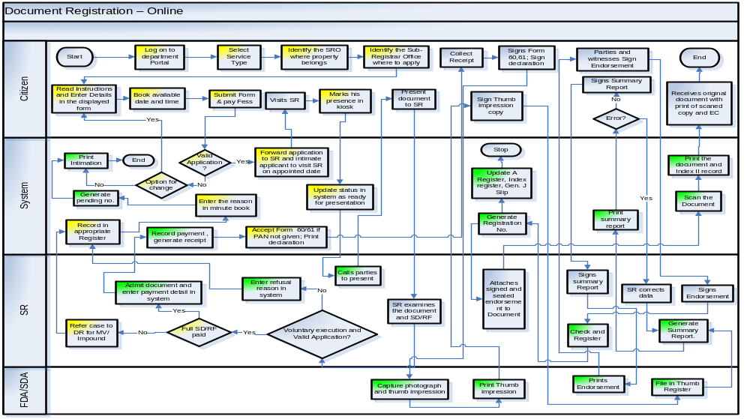
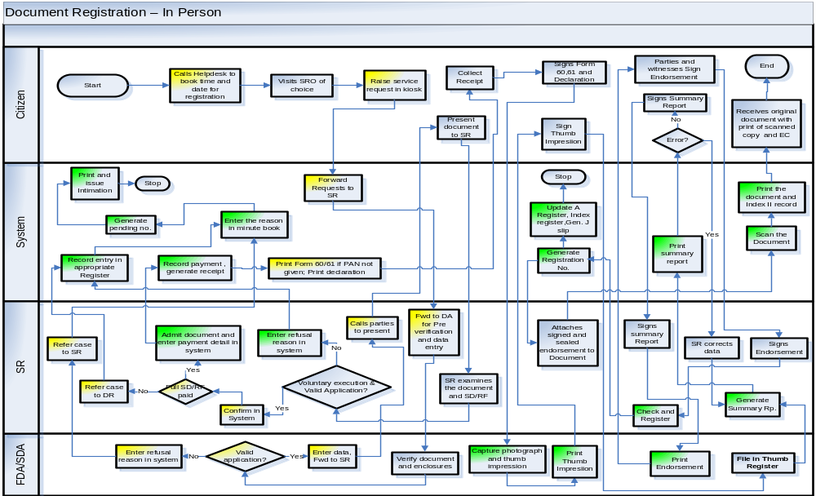

MOD 02 – Marriage Registration Module
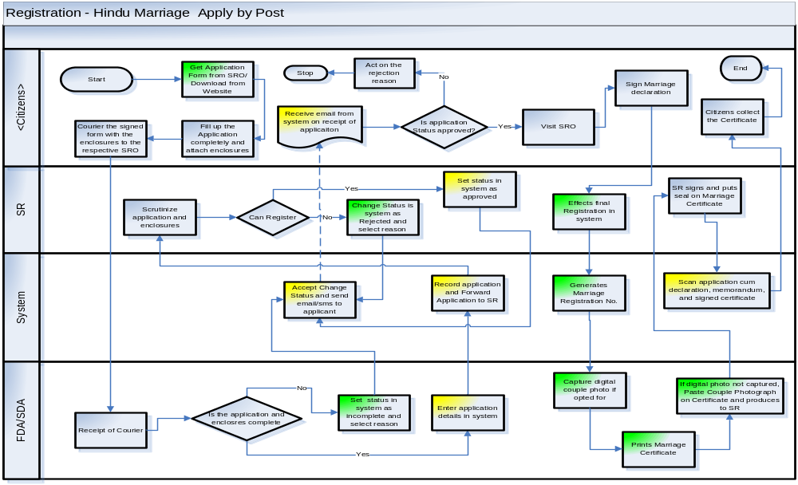
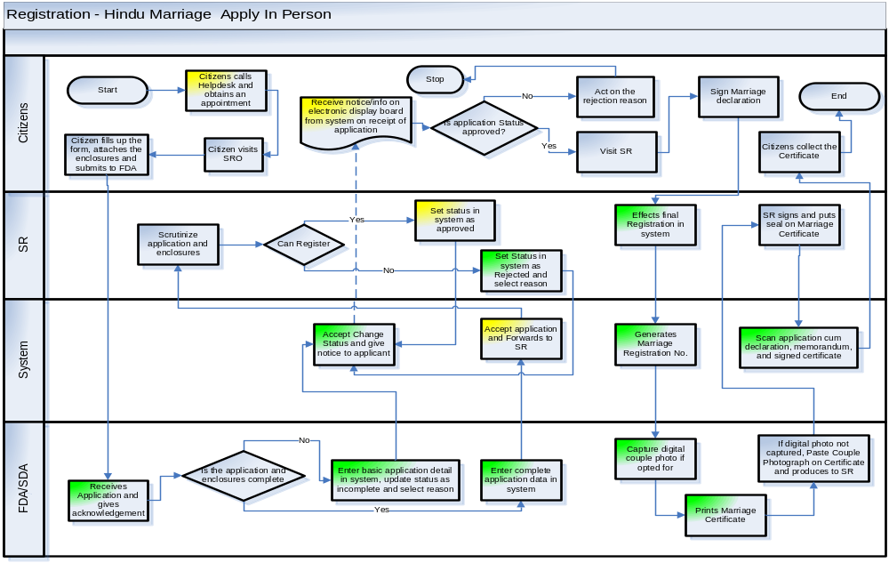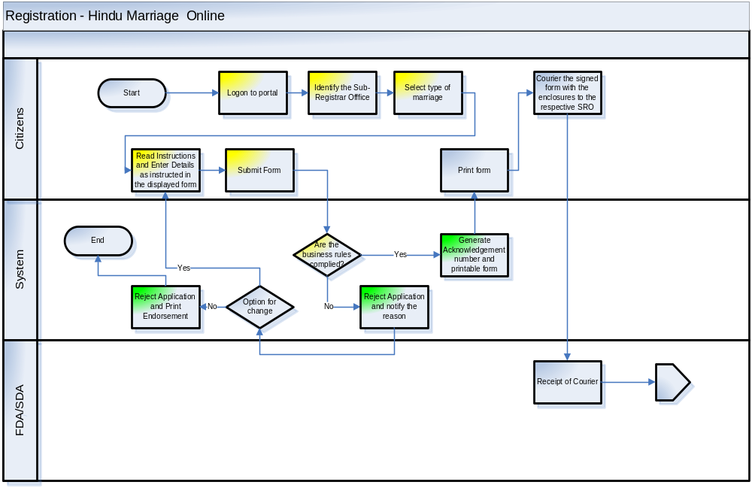
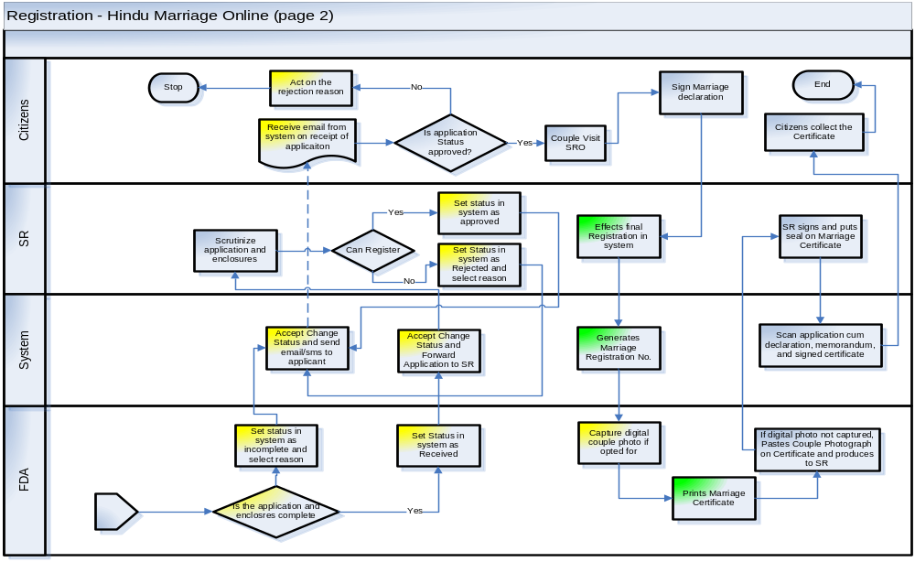
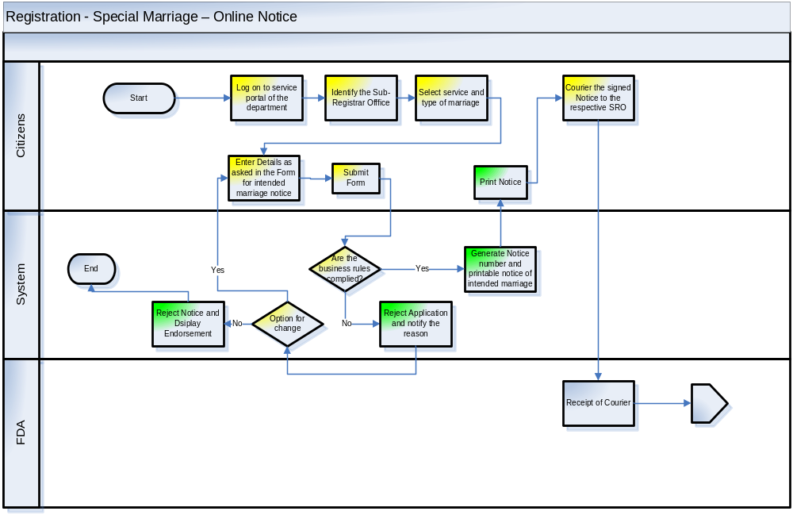
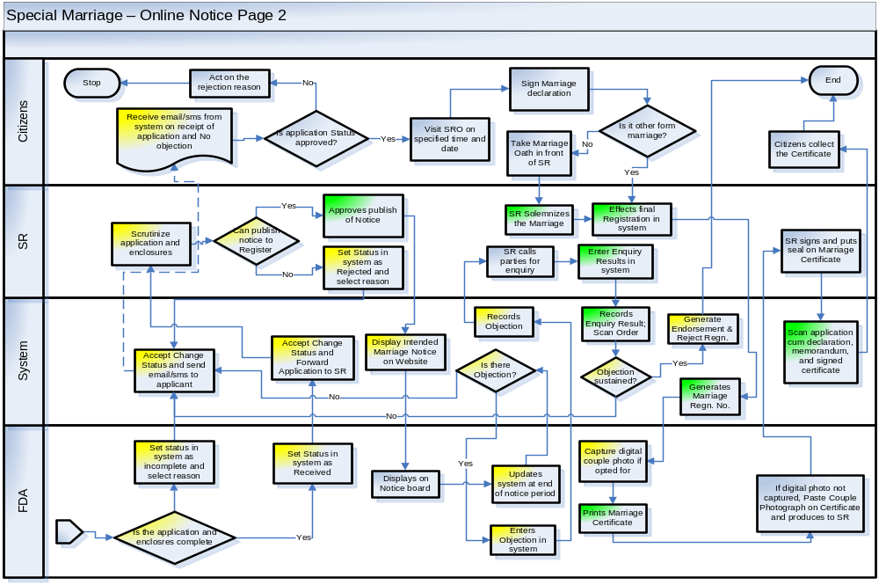
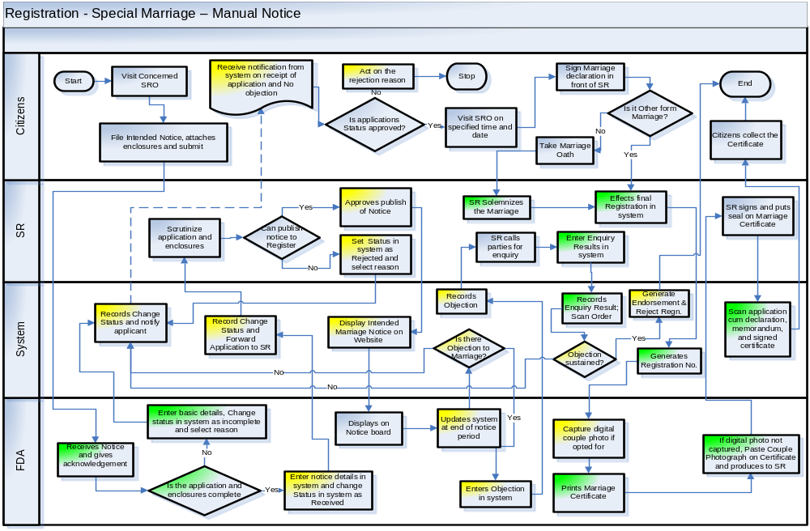

MOD 03 – Firm Registration Module
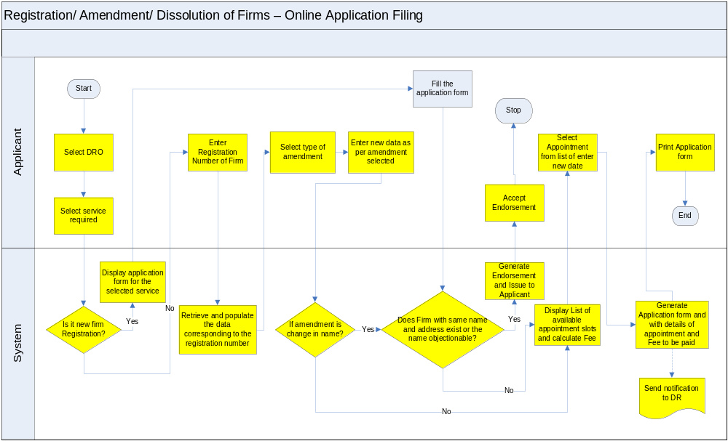
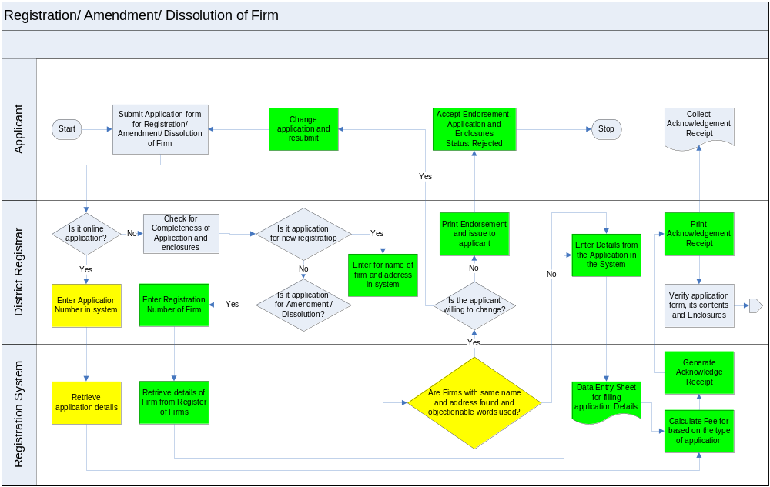
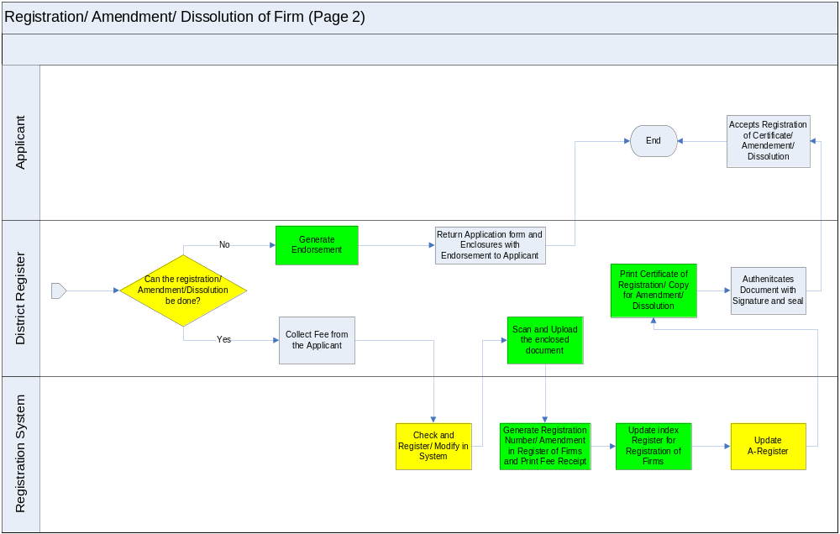

MOD 05 – Encumbrance Search Module
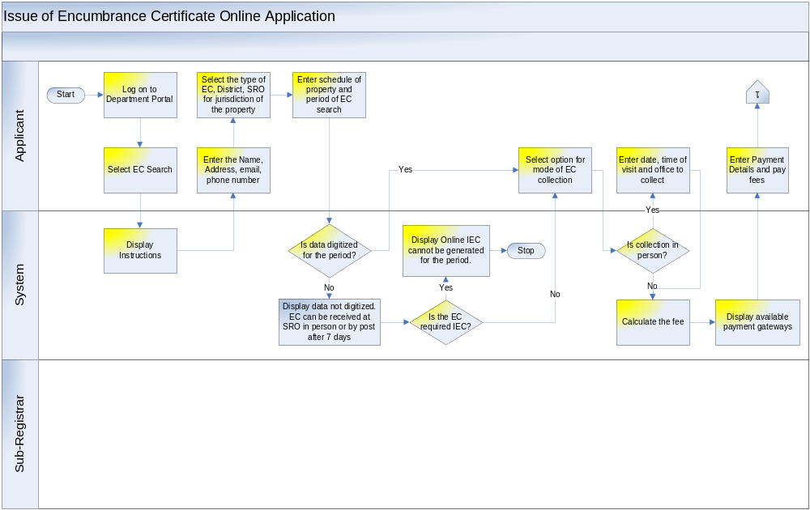
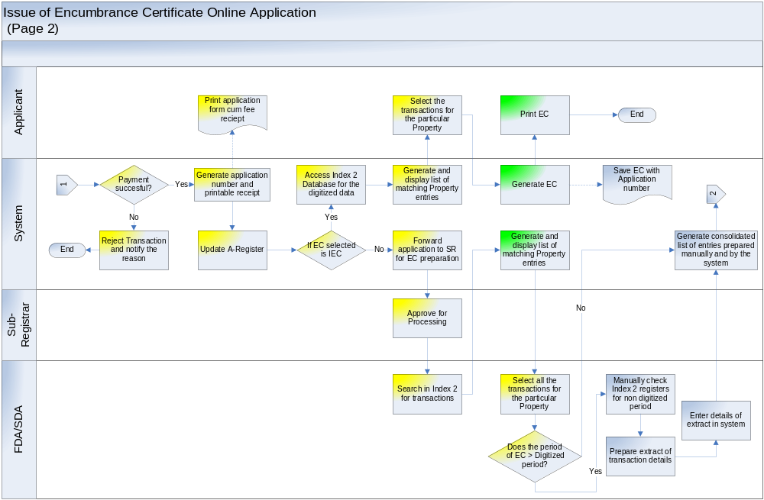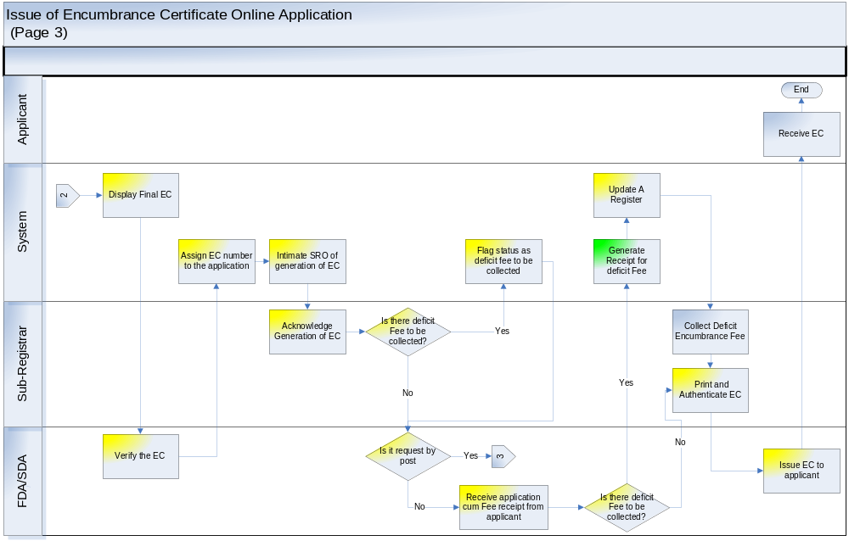
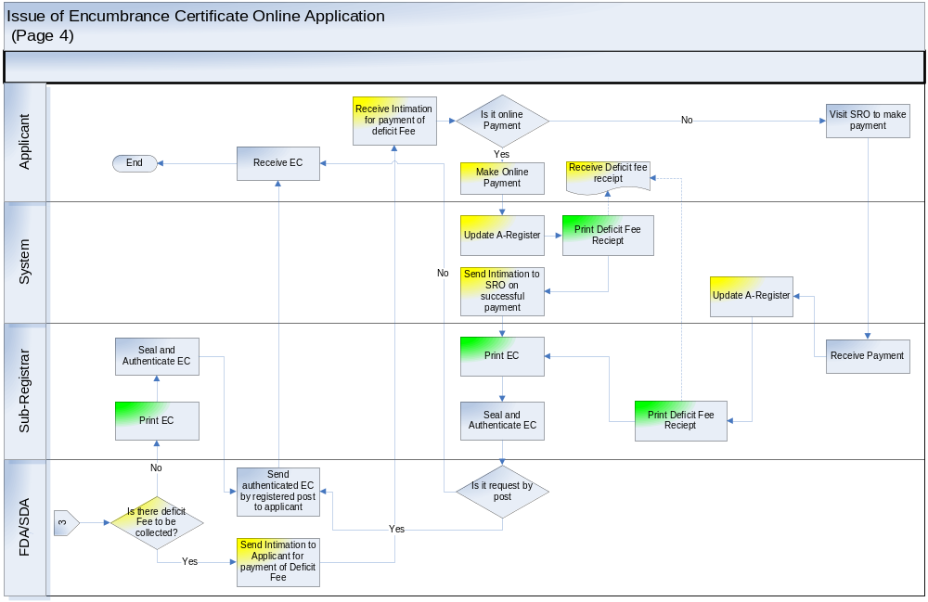
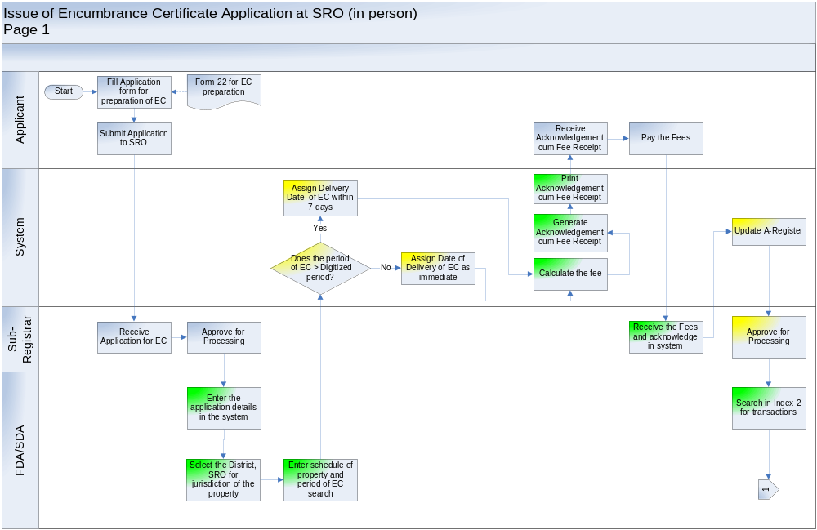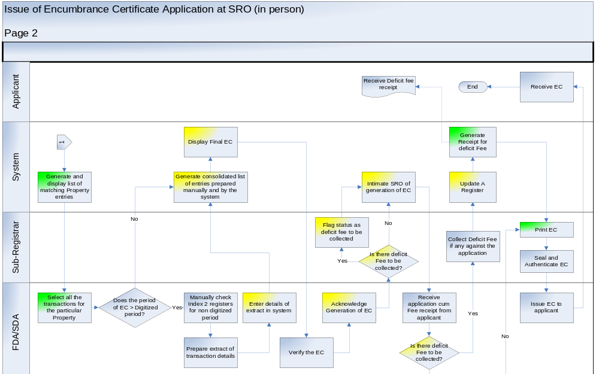

MOD 06 – Certified Copies Module
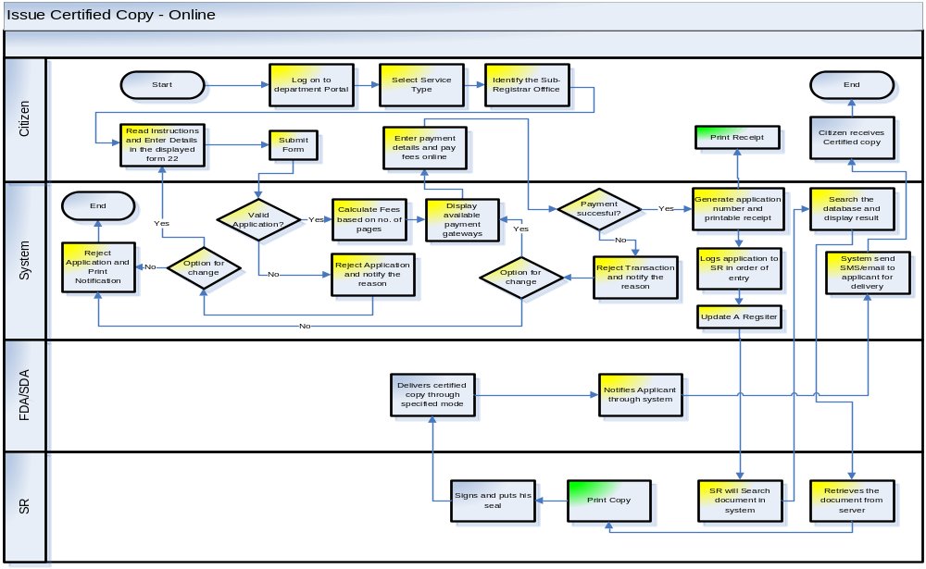
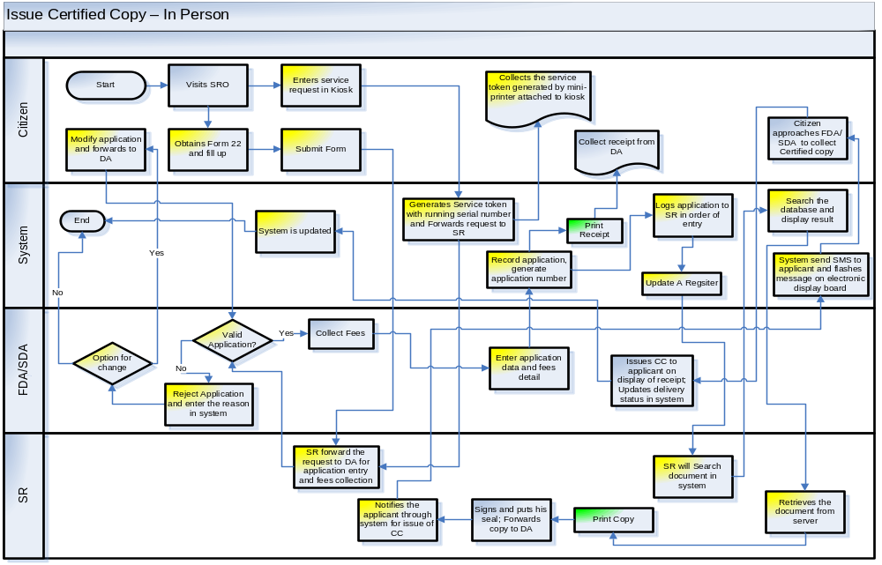

MOD 07 – Accounting Module
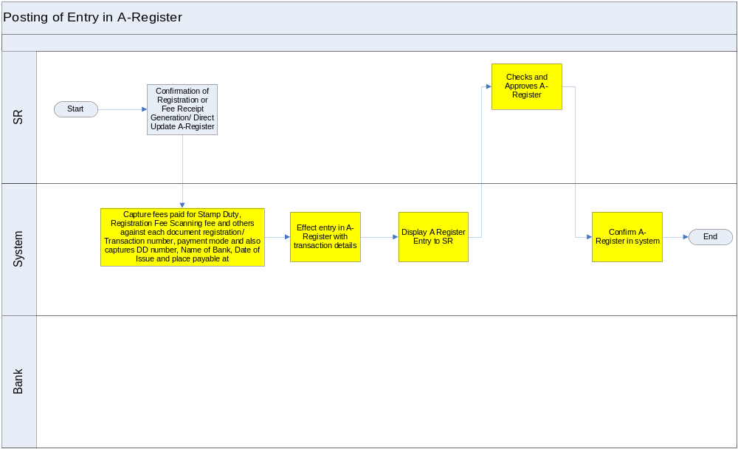
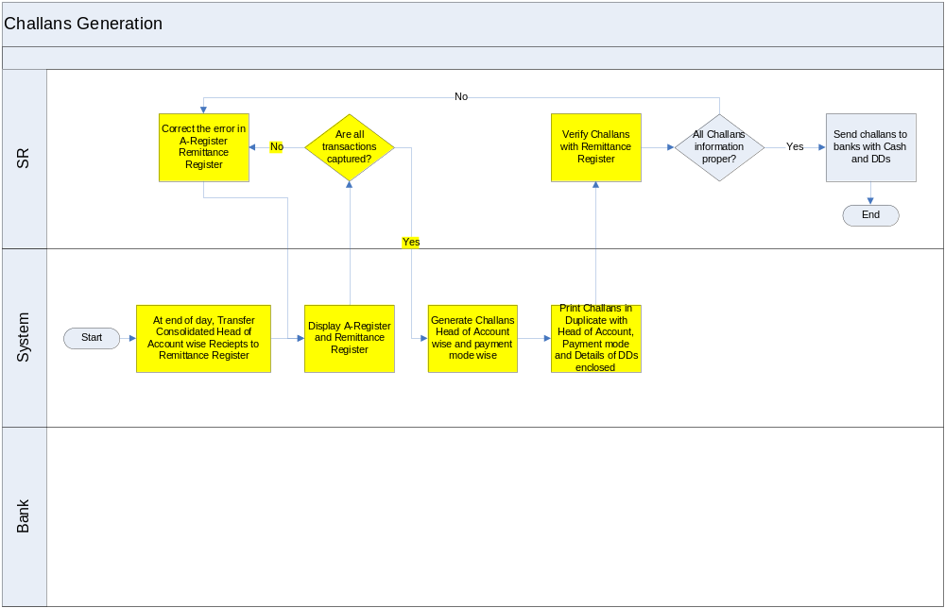
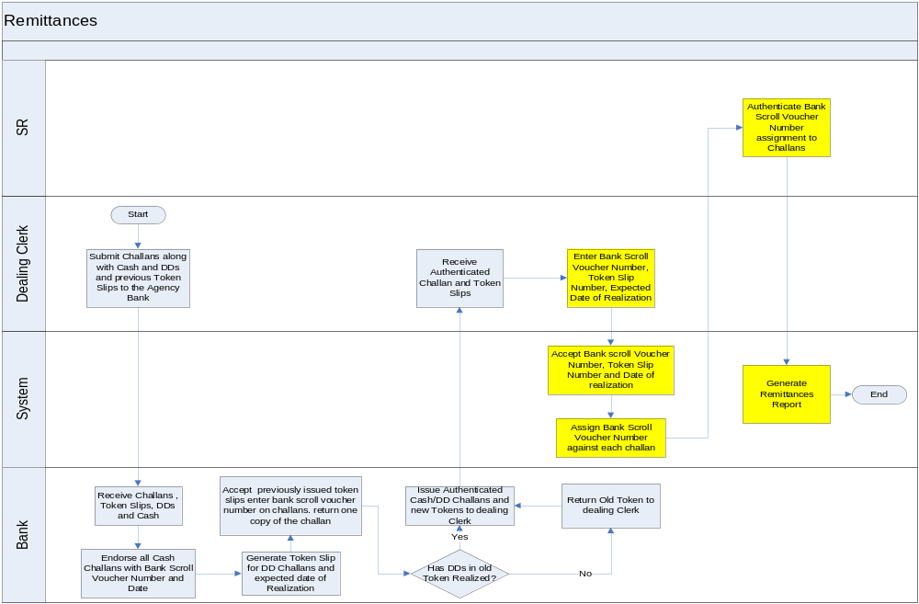
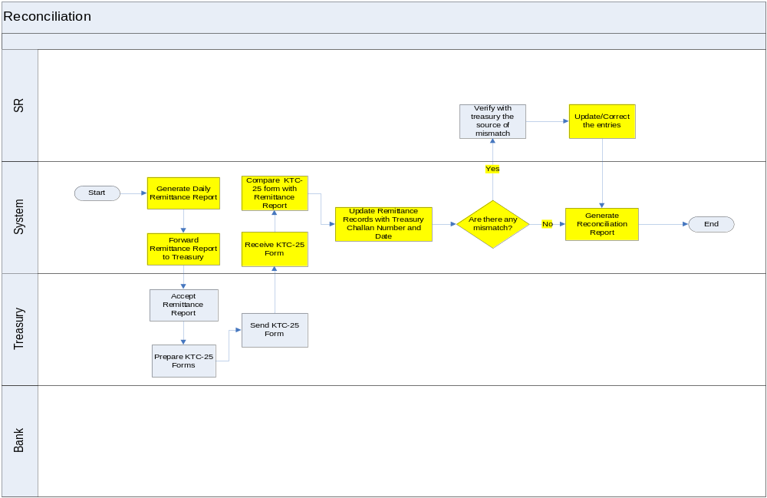

MOD 08 – Grievance Redressal Module
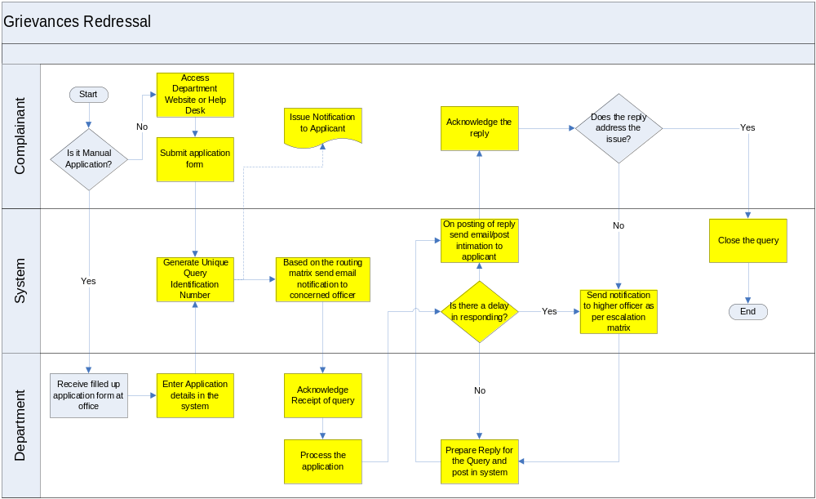

MOD 08 – Society Registration Module
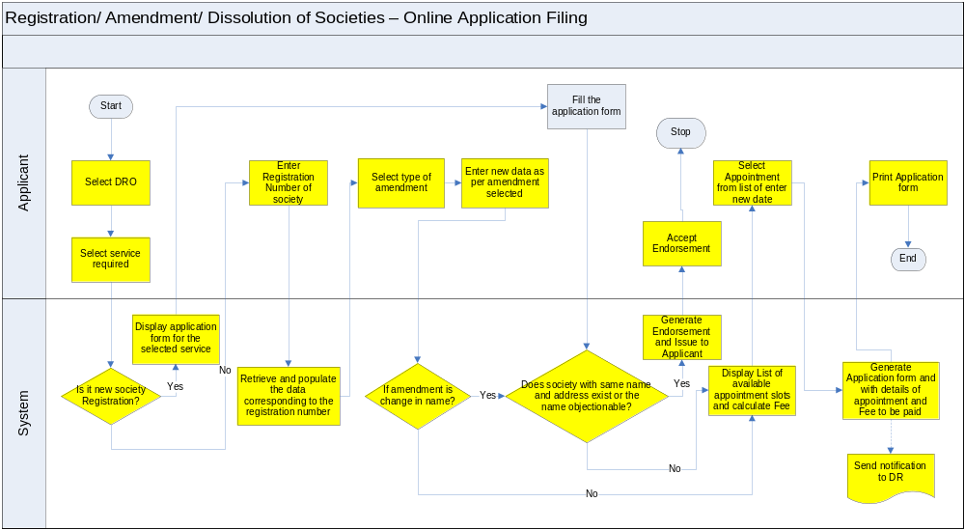

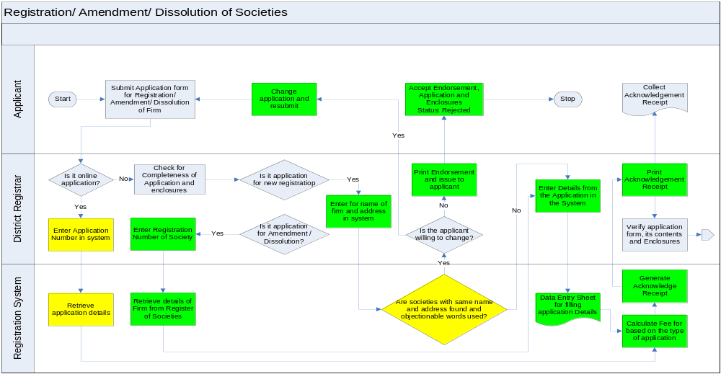

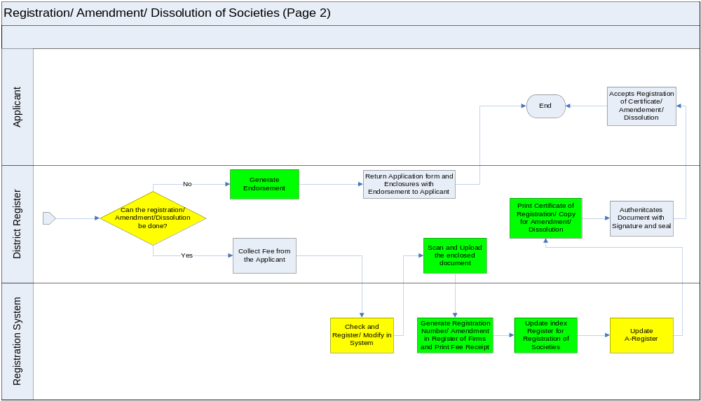

Annexure 3: External Interfaces
This section provides information exchange requirements and workflow for inter-department communications through interface being provided as a part of new Kaveri application.
- Departments will have read only access to the data from Kaveri system.
- Use of digital signatures will be supported by the system for authorized, secure access and also to ensure authenticated information exchange.
- Features will be built in the software to allow privileged access only.
- Authorization mechanism shall be built in for validation of data being exchanged.
- Encryption and decryption of data being exchanged should also be supported to ensure data security.

A: Revenue Department/SSLR (Mojani) /Bhoomi
Functional Requirement Specifications
Objective | DS&R  - Data validation to avoid error/forgery in furnished testimonials  - Correct identification of properties and available extents  - To avoid registration banned by law  - Speedy recovery of arrears of land revenue  - Obtain new survey numbers from SSLR and update its system  SSLR/Bhoomi/Revenue department  - Error free registration data from registration department to affect mutation and maintain RoR.  - Easy access to registered document  - Party contact details for intimation of mutation status  - Timely access to Form 81 declaration
Stakeholders/ Interface | Stakeholder/ Interface | Role/ Responsibilities
Stakeholders/ Interface | SR | - Log on to the New Kaveri Application to access information from SSLR, Bhoomi and Revenue Department applications through web services/APIs.  - During the registration process for immovable properties, fetch the Seller Name and property details from Bhoomi using Survey Number. The information received will include extent available for sale, information on restrictions on sale, government land, granted land, etc  - Also fetch the RTC and 11/e sketch data from Bhoomi and SSLR systems respectively.  - Obtain information for specified time period related to the following items.  - Detailed list of Government lands  - Detailed list of Granted lands  - Detailed list of lands granted to  SC/ST people  - Detailed list of lands converted for  non-agricultural purposes  The queries supported will depend on information required for various transactions and web services exposed by the respective systems.  - On a periodic basis, fetch details of arrears of land revenue recovered from Revenue Department system.
Stakeholders/ Interface | Bhoomi Authority | - On a periodic basis, fetch reports of J-slips generated during registration process by entering To and From date. (Read Only)  - New Kaveri Application will expose web services/APIs to Bhoomi to obtain the reports without logging into the New Kaveri application as part of integration between the systems.
Stakeholders/ Interface | SSLR Authority | - On a periodic basis, fetch Form-81 and related registration data for mutation by entering To and From date. (Read Only)  - New Kaveri Application will expose web services/APIs to SSLR system to obtain the data without logging into the New Kaveri application as part of integration between the systems.
Stakeholders/ Interface | Revenue Authority | - On a periodic basis, fetch details of arrears of land revenue (45A case details) by entering To and From date. (Read Only)  - New Kaveri Application will expose web services/APIs to Revenue Department system to obtain the data without logging into the New Kaveri application as part of integration between the systems.
Stakeholders/ Interface | System | - Authorize user access  - Search SSLR and Bhoomi database and display  - Detailed list of Government lands  - Detailed list of Granted lands  - Detailed list of lands granted to  SC/ST people  - Detailed list of lands converted for  non-agricultural purposes  - Arrears of Land Revenue  - Search Bhoomi database through Survey number and display RoR data, Seller Data, Extent, etc (Read Only)  - Search SSLR database through Survey number and display Survey Maps (11/e sketch for agricultural property)  - Transmit J slip form registration department system to Bhoomi database  - Receive acknowledgement for receipt of J-Slip from Bhoomi.  - Transmit Form 81 declaration with thumb impression form registration department system to SSLR database  - Send details of 11e sketches whose transaction have been registered.
Process Flow | Validation of RoR and Survey Maps  - The SR will click the validate button at the side of field containing Survey Number in the property schedule form.  - The corresponding RoR will be fetched from SSLR server and displayed in a new window.  - SR will validate the displayed RoR, with the physical RoR furnished by the presenter.  - In case of discrepancy, the presenter is informed about the same and asked to do the needful.  - Similarly, the SR will validate the survey map (11e Sketch) by displaying it from the SSLR server.  Transfer of J slips  - Every committed registration in the department will trigger a J slip, which contains the survey number appended with buyer’s name and address, date and place of registration and document number.  - SSLR authority will be able to view the logged J slip information on real time basis through authorized login to registration department system on a secured network.  - At the end of day, SR will validate the information and authorized J slips will be transmitted electronically by SR to SSLR server.  - System will keep log of all J slip transfers along with transfer time and delivery report etc.  Transfer of New Survey Number:  - For transfer of rights of a portion of land survey, entries in index records of registration department are made on parent survey number. However, the system must make provision to tag such entries as temporary.  - SSLR will send the new survey number electronically to Registration department through the proposed interface once mutation process is complete.  - Registration department system will log such entries in the interface with status displayed as temporary.  - It should trigger timely reminders to SR and SSLR authority to provide the new survey number.
Key Performance Indicators | - Response time to queries  - Authorized access control  - Chances of Error  - Downtime
Redesigned Forms and Registers | - Log in and authorization interface  - Search Forms for J slip, RTC, 11/e sketch and 45A cases  - Session and user logs  - Data transfer logs  - Service level logs  - User identification and authorization master
MIS Reports | - Day-wise and office wise transfer of J slips  - Day-wise and office wise view of 11/e sketches  - Day-wise and office wise view of RTC  - Day-wise and office wise transfer of 45A cases  - User and date wise access to external databases

B: Treasuries
Functional Requirement Specifications
Objective | - Quick access to accurate remittance details – It is required that the KTC-25 details are furnished to the department as soon as it gets entered in the treasuries database.  - Accurate remittance and its reconciliation – The data furnished by the treasuries must be accurate and complete.  - Transaction wise remittance – It is desirable that the individual transaction gets reconciled with corresponding remittances.
Stakeholders/ Interface | Stakeholder/ Interface | Role/ Responsibilities
Stakeholders/ Interface | SR | - Updates the remittance in system upon receipt of acknowledged Challan copy from bank. Bank scroll number and date of realization stamped on the duplicate Challan is entered in the corresponding Challan copy in the system.  - Approves the acknowledged electronic Challans to be posted in the system for download by local treasuries.  - Checks the Challan downloaded and reconciled by local treasuries  - Downloads the Challan reconciled by Treasury with Treasury Challan number and Challan date.  - Create KTC 25 from the list of reconciled Challans downloaded
Stakeholders/ Interface | Local Treasury Authority | - Obtains bank scroll from the local bank where SR remits the amount to be deposited in treasuries.  - At time of entering Challan information in its system, logs on to the secured network to access registration department system through authorized user id and password from identified IP address of his system.  - Checks the log of Challans posted by Registration department and finds out the ones listed in the bank scroll.  - He downloads the reconciled Challan.  - For the Challans acknowledged in the bank scroll that matches the bank scroll number, date of realization and remitted amount in the corresponding challan posted in the registration department system. He enters the treasury Challan number and date in the system and then clicks the reconciled button against the posted Challan.  - The downloaded Challan details are automatically entered in treasury system in their format.
Stakeholders/ Interface | System | - User authorization  - Accept Challan acknowledgement by capturing corresponding bank scroll number and date of realization  - Post the acknowledged Challan for view of local treasury authority (LTA)  - Record treasury Challan date and number entered by LTA.  - Allow download of reconciled Challan details  - Send reminder to LTA upon posting of acknowledged Challans by SR  - Send reminder to SR upon reconciliation of Challan by LTA  - Generate MIS
Process Flow | - Dealing assistant remits the money to bank and obtains acknowledgement against same  - SR updates the acknowledged Challans in system by entering bank scroll number and date of realization  - System posts the acknowledged Challan at Treasury interface for view and download by them  - LTA obtains bank scroll from local bank and login to registration department interface  - For the Challans mentioned in the scroll, LTA locates them in the log posted by registration department. Match the bank scroll number, date of realization and remitted amount in posted Challan against that in the bank scroll.  - LTA downloads the Challans  - He updates treasury Challan number and date in the Challan posted by the registration department  - He confirms reconciliation in the registration department interface  - SR downloads the Challans reconciled by Treasury with Treasury Challan number and Challan date.  - He creates KTC 25 from the list of reconciled Challans downloaded, through the system
Key Performance Indicators | - Download time  - Probability of un-authorized access  - Probability of Error  - Downtime
Redesigned Forms and Registers | - Log in and authorization interface  - Reconciliation Form  - Session and user logs  - Data transfer logs  - User identification and authorization master
MIS Reports | - Day-wise and office wise posting of Challans by SR  - Day-wise and office wise view of Challans by LTA  - Day-wise and office wise download of reconciled Challans

C: Urban Local Body
Functional Requirement Specifications
Objective | DS&R  - Web Based Data validation to avoid misrepresentation/suppression of data in furnished testimonials  - Correct identification of properties  - Utilize GIS and Property Tax data for correct Market Valuation  ULB  - Error free registration data from registration department to affect mutation  - Easy web based access to registered document for validation  - Party contact details for intimation of mutation status
Stakeholders/ Interface | Stakeholder/ Interface | Role/ Responsibilities
Stakeholders/ Interface | SR | - Log on to the secured network to access Nirmal Nagara database through authorized user id and password from identified IP address of his system.  - Runs query to fetch property details by entering Property ID(PID) as issued by the Urban Local Body for property tax valuation  - Obtain GIS data for verifying the abetting property, roads, parks etc. for valuation during the registration process.
Stakeholders/ Interface | Urban Local Body | - Log on to the secured network to access registration department database through authorized user id and password from identified IP address of his system.  - On a periodic basis, fetch details of transactions on the properties situated under the notified jurisdiction based on PID and update change in ownership information to effect mutation.
 | System | - Authorize user access  - Search ULB database using PID and key search criteria and display  - GIS Data of the Property  - PTIS information  - Search ULB database using PID (Read Only)  - Search ULB database through PID and display GIS Maps  - Rule based transmission of Property Registration data from registration department system to ULB for mutation purpose.
Process Flow | Validation of Khata Information and Property Identification  - The SR will click the validate button at the side of field containing PID in the property schedule form.  - The corresponding GIS and PTIS will be fetched from ULB server and displayed in a new window.  - SR will validate the displayed GIS and PTIS, with the physical data furnished by the presenter.  - SR will check the furnished guidance slip and validate the property valuation based on GIS data displayed  - In case of discrepancy, the presenter is informed about the same and asked to do the needful.  Transfer of Registration Data  - Every committed registration in the department will trigger a rule based transmission of details, which contains the PID appended with buyer’s name and address, date and place of registration and document number.  - ULB authority will be able to view the logged information on real time basis through authorized login to registration department system on a secured network.  - At the end of day, SR will validate the information and authorized registration information will be transmitted electronically by SR to ULB server.  - System will keep log of all transfers along with transfer time and delivery report etc.
Key Performance Indicators | - Response time to queries  - Authorized access control  - Chances of Error  - Downtime
Redesigned Forms and Registers | - Log in and authorization interface  - Session and user logs  - Data transfer logs  - Service level logs  - User identification and authorization master
MIS Reports | - Day-wise and office wise transfer Registration information  - User and date wise access to external databases

D: Accountant General
Functional Requirement Specifications
Objective | - Faster resolution of discrepancies – It is intended that the unnecessary delays in responses and communication are minimized for faster resolution of paras.  - Centralized monitoring – The communication is required to be transparent inspiring centralized monitoring from both department and AG office.
Stakeholders/ Interface | Stakeholder/ Interface | Role/ Responsibilities
Stakeholders/ Interface | System | - Validate authorized user  - Accept upload of LAR, audit paras, draft paras, C&AG paras by authorized users  - Allow download of LAR, audit paras, draft paras, C&AG paras by authorized users  - Search LAR  - Search paras  - Record status update of various paras as posted/clarified/rejected/dropped/pending etc.  - Transfer response/clarifications to various paras by appropriate offices  - Record and share AG opinion on paras  - Maintain audit trail of actions made on various paras  - Send acknowledgement for communications received  - Index and archive LAR, audit paras, draft paras and C&AG paras
Stakeholders/ Interface | SR | - Posts response to the audit paras forwarded to him for clarification.
Stakeholders/ Interface | DR | - Receives and downloads LAR and paras sent by AG office  - Reviews and forwards paras to appropriate authority for further action  - Posts response to the paras and upload the support documents
Stakeholders/ Interface | IGR | - Receives and downloads C&AG paras sent by AG office  - Reviews and forwards paras to appropriate authority for further action  - Posts response to the paras and upload the support documents
Stakeholders/ Interface | AG Authority | - Log on to the secured network to access registration department database through authorized user id and password from identified IP address of his system.  - Post and Upload the LAR, audit paras, draft paras, C&AG paras as and when ready  - Post opinion on various paras whenever needed  - View and download response/clarifications on various paras by registration department authority  - Update status of various paras as dropped, rejected or pending etc.
Key Performance Indicators | - Data/Report Transfer time  - Downtime
Redesigned Forms and Registers | - Log in and authorization interface  - Search Forms for LAR, audit paras, draft paras, C&AG paras, Para responses  - Form for upload of LAR and various Paras  - Form to post response/opinion to paras  - Session and user logs  - Data transfer logs  - User identification and authorization master
MIS Reports | - Day-wise and office wise transfer of LAR/Paras  - Day-wise and office wise view of LAR/Paras  - Day-wise and office wise posting of responses  - User and date wise access by AG office  - Para wise audit trail report  - Status of various paras within specific period

E: Income Tax Department
Income tax act requires, on a mandatory basis, that PAN of the buyer must be disclosed and passed on to the income tax department for any transaction of more than Rs 5 lacs that he or she enters into. For the buyers not having PAN number, they need to submit duly filled up and signed Form 60/61 with the SR or DR. It makes imperative for the SR or the DR who is registering a transaction more than 5 lacs to take the PAN number or Form 60/61 from the parties and forward the same to the IT department on periodic basis.
The department also needs to submit additional Annual Information Report (AIR) on all transactions greater than 30 lacs to the IT department.
Information usage by IT Department:
- Identification of new tax payers – The PAN or Form 60/61 data is used by the IT department to identify new tax payers as well as to assess the income of individuals.
- Track transaction greater than 5 lacs – Tracking the high value transactions helps the IT department to administer its primary functions and reduce the chances of tax evasion.
Information usage by DS&R:
- PAN Card Validation – The department can use the PAN card number to validate the personal detail of the parties in the Income Tax department database. It can serve as an additional identification check by the department.
- The information relating to actual market value of the property as disclosed in the Income Tax Returns filed with Income Tax Department should be shared with the Department of Stamps and Registration. This helps in checking under valuation of properties. In case of undervaluation, such documents should be referred for determination of market value under section 45-A (3) of the Registration Act, 1908. The system should match these data of the two departments and find out the mismatch if any.
Objectives:
- Reduced administrative burden for both departments – Collection, consolidation and transfer of complete and correct data (PAN, Form 60/61 and AIR) to income tax department is additional workload to the SRO which is not related to citizen service. Even, following up with 234 SRO’s on part of IT department is a very taxing affair.
- Easy and faster transfer of data – The department looks forward to ease and faster means of data transmission in a transparent, reliable and secure manner.
- Accurate transaction details – The data capture, validation and transmission needs to be error free to avoid repeat efforts and delays.
- Validation with IT Returns to check undervaluation

Information available for exchange from Department:
Following information will be made available in the database of the department for use by IT department with Read Only Privilege.
- Form no 60/61
- PAN furnished during registration
- Sellers and Purchasers details – Name and Address
- Photo and Thumb Impression
Proposed interaction
IT department at present is not ready for direct system interface with the department. However, it looks forward to electronic transmission of Form 60/61 and AIR from the department preferably in XML form to its server through a secured network. The department, in turn, can use the PAN database of the IT department which is already available in a public domain on web for its own validation.
Once registered, Form 60/61 may be transmitted electronically to IT department server in XML format. The system will maintain a log of all such transmissions with date, time, transfer time and status.
The AIR can be periodically generated through system by the SR based on captured registration data. The same can be again sent electronically in XML format to IT department server.
Similarly, details of the properties and owner, as declared in IT returns, with its valuation must be transmitted to Registration department’s system in XML form by Income Tax department’s system. The department’s system shall import the data and match the declared value (In IT return) with corresponding values in its registration record. The mismatch must be logged and reported to appropriate authority.

E: Aadhar (UID)
Functional Requirement Specifications
Objective | - Authentication of identity of the parties and the witnesses involved in the registration process using UID number and biometric information.
Stakeholders/ Interface | Stakeholder/ Interface | Role/ Responsibilities
Stakeholders/ Interface | System | - Should comply with AUA(Authentication User Agency) norms as laid out by UIDAI  - Send user data(UID number and biometric parameters) from KAVERI to ASA server by digitally signing the same so that any tampering with the data during the transit from AUA (Kaveri Server) to UIDAI can be detected by the UIDAI application  - The system should be able to integrate with a certified UIDAI ASA(Authentication Service Agency) to pass on the authentication request parameters to the ASA through a secure channel for subsequent relay of the authentication request to UIDAI servers by the ASA  - Receive the UIDAI response from the ASA over a secure channel  - Check the digitally signed response from the UIDAI application for tampering.  - Support for all authentication modes viz biometric authentication, One time password(OTP) etc provided by UID  - Maintain Audit trails for all such transactions.
Stakeholders/ Interface | ASA(Authentication Service Agency) | - Should comply with ASA(Authentication Service Agency) norms as laid out by UIDAI  - Integration with UID database through web service APIs  - Integration with New Kaveri Application through web service APIs  - Forward the response from the UIDAI application to the KAVERI application through a secure channel  - Support for all authentication modes viz biometric authentication, One time password(OTP) etc provided by UID
Stakeholders/ Interface | SR | - Enters UID number and the biometric data of the concerned parties in the KAVERI application  - Receives the authentication response from UID through KAVERI and verifies identity of parties, witnesses, etc.
 | Buyer / Seller /Parties/Applicants/ Witnesses | - Provide UID numbers and biometric data(fingerprints) as inputs to the KAVERI system
Process Flow | - SR obtains the UID number from the parties and thumb impression is captured using the thumb scanner and they are entered into the system(Kaveri Application) at SR Office  - Data is captured and encrypted by the system at SRO  - The encrypted data is forwarded to central KAVERI server(AUA) through KSWAN.  - AUA digitally signs the data to ensure data integrity during transit  - AUA forwards the data to ASA over a secure channel  - ASA receives the authentication request data from AUA and forwards the same to the UIDAI server on the behalf of AUA for authentication response  - UIDAI returns the digitally signed authentication response to ASA  - ASA forwards the authentication response received from UIDAI server to AUA(Kaveri)  - AUA receives the authentication response from ASA and verifies the digital signature to determine if the data was tampered with during transit.  - The authentication data received from UIDAI is sent to the SRO through KSWAN where the SR will be able to verify the identity of the parties using the name, demographic data, photo etc received from UIDAI.
Key Performance Indicators | - Time taken by the system to display the response to authentication query
Redesigned Forms and Registers | - Field in the e-Forms to capture UID number of the concerned parties  - Session and user logs  - Data transfer logs
MIS Reports | - Day-wise and office wise user authentication reports.  - Audit trail report

Annexure 4: Work-flow in core services

The following table illustrates the workflow in core department services.
Sl. | Service | Activity | Channel | Actor | Authoriza-tion | Expected time
1 | Document Registration | - Data entry  - Presentation of Document  - Admission of execution  - Scrutiny, online validations and Collection of proper Stamp Duty and Registration Fee  - Identification of Parties  - Print Receipt, Form 60/61 and 81/A declaration; Capture Photograph and Thumb Impression, Print Thumb impression, Get thumb impression copy signed; Scan presenter’s thumb to generate summary report on his validation of data entered; Print summary report; Print Endorsement  - Check and Register  - Scan the document and upload; Print the scanned document and index II record | SRO / B1, K1 / Nemmadi / Portal  SRO  SRO  SRO  SRO  SRO  SRO  SRO | At SRO:  Operator/SR  At B1, K1/Nemmadi:  CSC Operator  At Portal:  Applicant  Applicant  SR  SR  SR  Operator  SR  Operator | SR  SR | 20 minutes (For 2 Parties and 2 schedule of properties)
2 | Marriage Registration | - Data entry / Application /Preliminary verification  - Scrutinize application and approve; Register  - Print Receipt, Capture Photograph, Print Marriage Certificate;  - Scan application cum declaration, Memorandum, signed certificate, Deliver and update the system. | SRO / B1, K1 / Nemmadi / Portal  SRO  SRO  SRO | At SRO:  Operator  At B1, K1/Nemmadi:  CSC Operator  At Portal:  Applicant  SR  Operator  Operator | SR | 10-15 Minutes
3 | Issue of Encumbrance Certificate | - Data entry for the application  - Generation of Acknowledgement cum fee receipt against payment of fees  - Receive fees, issue receipt, update system and approve processing  - Search and display Encumbrance Record; Generate, verify search record and acknowledge EC generation  - Collect deficit EC fees, if any, and approve certificate generation; Print, authenticate and seal EC  - Issue EC | SRO / B1, K1 / Nemmadi / Portal  -Do-  -Do-  -Do-  SRO  SRO/Postal Address | At SRO:  Operator  At B1, K1/Nemmadi:  CSC Operator  At Portal:  Applicant  -Do-  SR  Operator/FDA  /SDA  SR  Operator | SR  SR | 10 Minutes
4 | Issue of Certified Copy | - Verify and enter data for CC application  - Generation of Acknowledgement cum fee receipt against payment of fees  - Receive fees, update system; Search document, download and print;  Authenticate and forwards to operator/DA.  - Issue CC to applicant on producing the receipt; Update system. | SRO / B1, K1 / Nemmadi / Portal  -Do-  -Do-  SRO  SRO/Postal Address | At SRO:  Operator  At B1, K1/Nemmadi:  CSC Operator  At Portal:  Applicant  -Do-  SR  SR  Operator | SR | 5 Minutes
5 | Firm Registration | - Verify and enter data for Firm Registration/ Amendment/ Dissolution application  - Generation of Acknowledgement cum fee receipt against payment of fees  - Receive fees, update system; Register and Generate certificate; Authenticate Certificate  - Issue Certificate/endorsement to Applicant | DRO / B1, K1 / Nemmadi / Portal  -Do-  DRO  DRO | At DRO:  Operator  At B1, K1/Nemmadi:  CSC Operator  At Portal:  Applicant  -Do-  DR  Operator | DR | 10 Minutes
Table 14: Workflow Details

